Contents
POWER BI 4
POWER BI WORKFLOW 4
POWER BI – BACKEND & FRONTEND LAYERS 4
POWER BI BACKEND 5
POWER BI FRONTEND 7
PUTTING THE ENTIRE POWER BI WORKFLOW TOGETHER 14
STORAGE AND CONNECTION MODES 15
IMPORT MODE 15
DIRECTQUERY 15
LIVE CONNECTION 16
COMPOSITE MODEL 16
EXTRACTING DATA FROM WEB 17
DATA QA AND PROFILLING TOOL IN POWER QUERY EDITOR 18
COLUMN QUALITY 19
COLUMN DISTRIBUTION 20
COLUMN PROFILE 21
TEXT TOOLS 23
DATE AND TIME TOOL 24
INDEX AND CONDITIONAL COLUMN 25
INDEX COLUMN 25
CONDITIONAL COLUMN 25
CALCULATED COLUMN BEST PRACTICES 26
GROUPING AND AGGREGATION 27
GROUP BY – BASIC 28
GROUP BY – ADVANCED 28
PIVOTING AND UNPIVOTING 28
MERGING AND APPENDING QUERIES 28
MERGE QUERIES(TABLE JOINS) 28
APPEND QUERIES 33
DATA-SOURCE SETTINGS 39
REFRESH QUERIES 40
CREATING DATA MODEL 41
NORMALIZATION 42
FACTS & DIMENSION TABLES 43
FACT TABLE — DATA TABLE 43
DIMENSION TABLE — LOOKUP TABLE 44
HOW FACT AND DIMENSION TABLES WORK TOGETHER? 44
SHARED DIMENSION TABLE 45
PRIMARY AND FOREIGN KEYS 46
ASSIGNING PRIMARY KEY TO A COLUMN 46
MODEL VIEW 47
CREATING RELATIONSHIP 47
OPTION 1- DRAG AND DROP 48
OPTION 2 49
EDITING RELATIONSHIP 50
ACTIVE & INACTIVE RELATIONSHIP 51
MODEL SCHEMA 55
STAR SCHEMA 55
SNOWFLAKE SCHEMA 56
CARDINALITY 57
CONNECTING MULTIPLE FACT TABLE 57
EXAMPLE 58
EXAMPLE 2 58
FILTER FLOW 59
WHAT IS FILTER CONTEXT? 60
WHAT IS FILTER FLOW? 60
FILTER CONTEXT TELLS WHICH DATA SHOULD I CALCULATE? 63
FILTER FLOW TELLS - HOW DOES THAT FILTER REACH THE DATA? 63
WHY DOES FILTER DIRECTION MATTER? 64
HIERARCHIES 64
HOW TO CREATE HIERARCHY 65
USING THE HIERARCHY IN A MATRIX 66
DRILL FEATURES 67
DAX(DATA ANALYSIS EXPRESSION) 68
DAX AS A CALCULATED COLUMN 69
NOTES 70
STEPS TO CREATE CALCULATED COLUMN 70
DAX AS A MEASURE 71
IMPLICIT AND EXPLICIT MEASURES 71
QUICK MEASURES 75
CALCULATED COLUMN VERSUS MEASURES 76
DEDICATED MEASURES TABLES 77

POWER BI
MS Power BI is a self service business intelligence platform, which includes both desktop and web based applications for connecting, modelling and visualizing data

POWER BI WORKFLOW
Power BI Desktop into two conceptual parts:
- Backend → Power Query Editor: prepares the data.
- Frontend → Model View + Data View + Report View: organizes the prepared data, performs analytics, and presents the results.
The overall flow is: Data Sources → Power Query Editor → Data Model → DAX/Calculations → Reports & Visuals
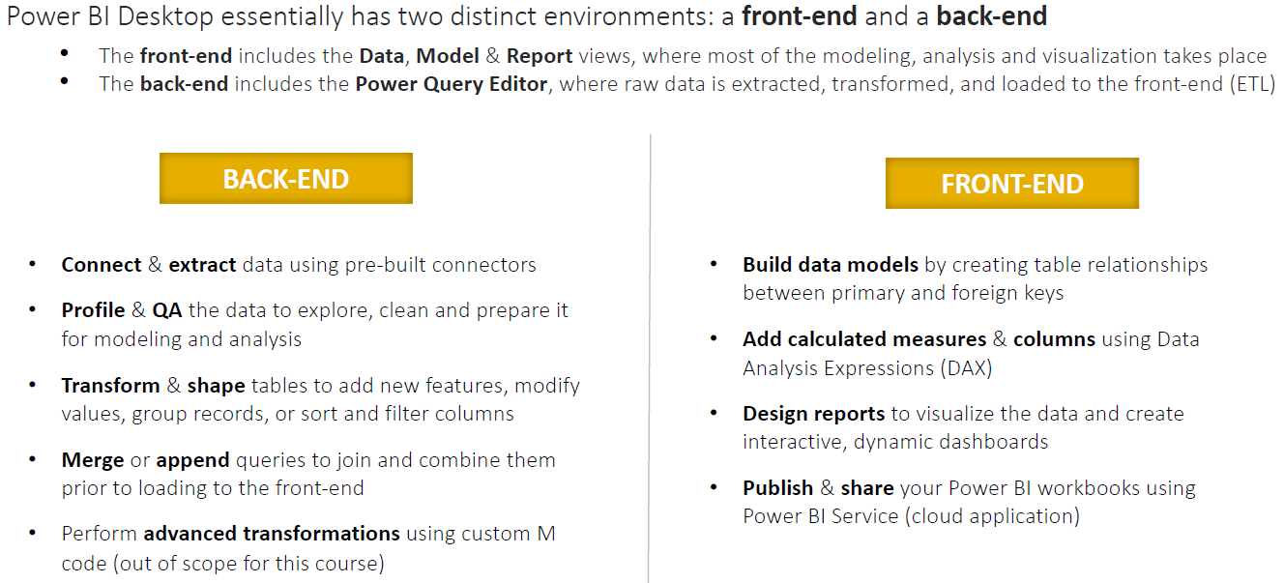

POWER BI – BACKEND & FRONTEND LAYERS
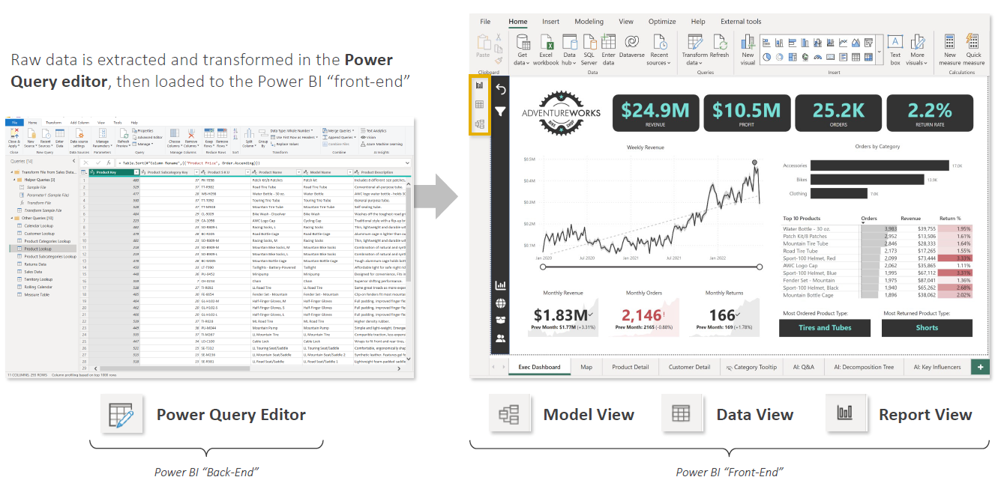
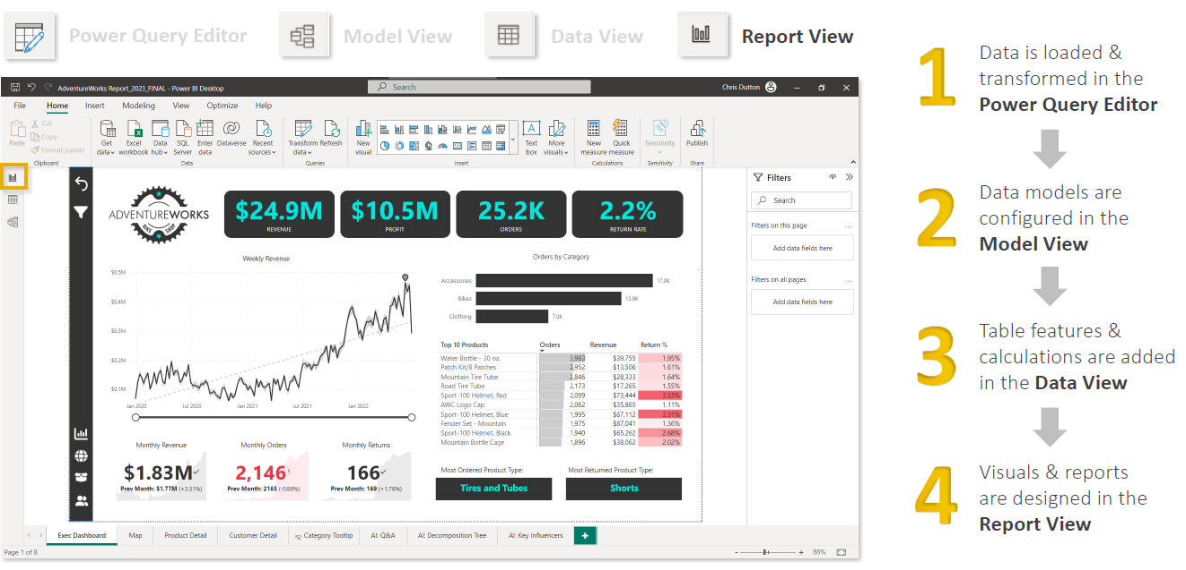

POWER BI BACKEND
- The Power Query Editor is essentially the data preparation / ETL layer of Power BI.
- You connect Power BI to raw data sources such as Excel, CSV, SQL Server, SharePoint, APIs, databases, etc.
- Power Query then lets you extract, clean, transform, and combine that data before it enters the Power BI model.
- Typical Power Query operations include removing unnecessary columns, filtering rows, changing data types, handling null values, splitting or merging columns, pivoting/unpivoting data, joining tables, appending datasets, and creating transformation logic.
- For example, suppose your source contains:
Order Date | Customer | Product | Sales
01/01/26 | ABC | Laptop | 50000
02/01/26 | XYZ | Mouse | NULL
- In Power Query, you might correct the data types, replace or remove the null value, standardize product names, merge customer information from another table, and remove columns you don't need.
- Power Query answers: "How should I prepare and transform my raw data?"
- Power Query transformations are primarily written in the M language, although most users create them through the graphical interface.

POWER QUERY EDITOR
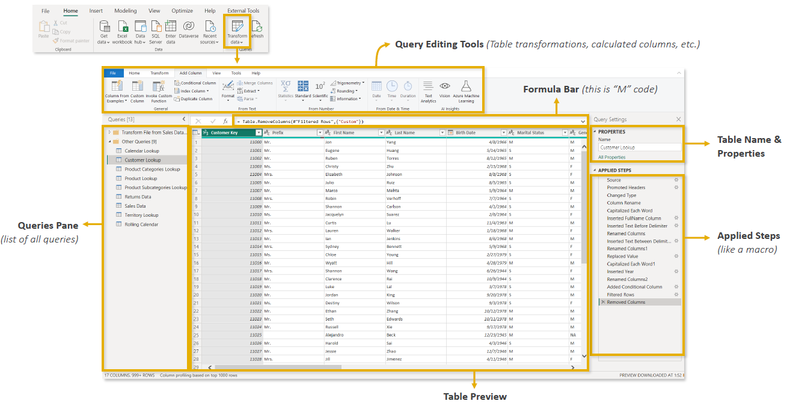
- Each Applied Step in Power Query represents an M expression/transformation, but there is an important nuance: Power Query does not necessarily execute each step separately against the source.
- Each step takes the result of the previous step and produces a new result.
- Each Applied Step represents M logic, and the steps are logically evaluated in sequence
For example:  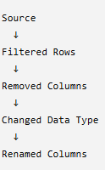 | Behind these steps, Power Query generates M code conceptually like:  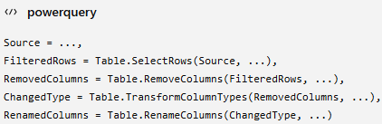
- Power Query Editor is the main workspace in Power BI for connecting, cleaning, transforming, and preparing data before it is loaded into reports.

KEY COMPONENTS OF THE POWER QUERY EDITOR
- Query Editing Tools (Top Ribbon)
- Contains tools for shaping and transforming data.
- Includes options to clean, filter, merge, split, and modify data.
- Formula Bar
- Displays M Code, the language used by Power Query.
- M Code is automatically generated when you perform transformations.
- Queries Pane (Left Side)
- Lists all data queries/connections.
- Allows you to select, view, edit, and manage queries.
- Each query represents a dataset or table.
- Data Preview (Center)
- Shows a preview of the selected query.
- Used for validating data, changing column types, renaming columns, and checking transformations.
- Properties Pane (Right Side)
- Displays query properties, especially the table name.
- Applied Steps Pane
- Records every transformation as a step.
- These steps are automatically replayed whenever data is refreshed.

TYPES OF CONNECTORS
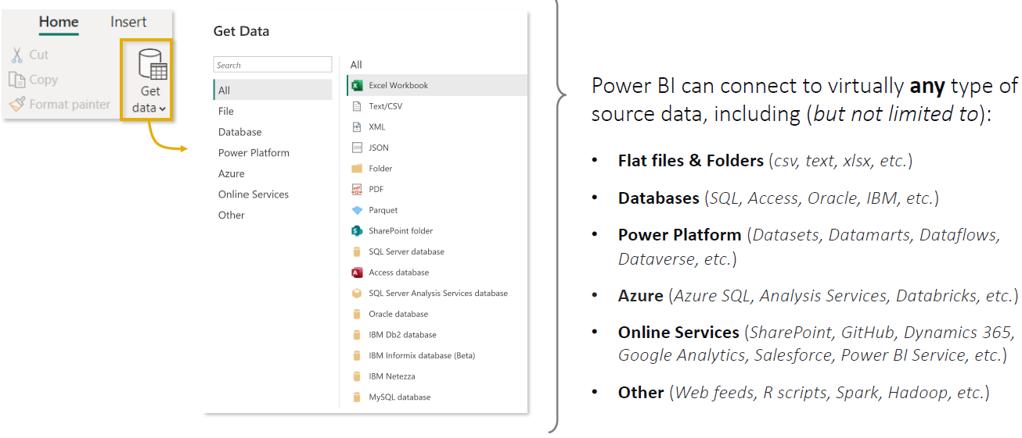
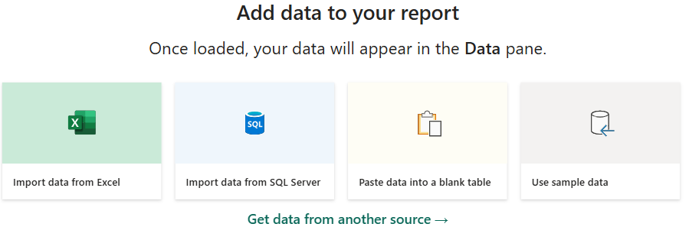

POWER BI FRONTEND
- After Power Query has prepared the data, you primarily work with three views:Model View → Data View → Report View
- They have different responsibilities, although in practice you can move between them rather than following a rigid sequence.

IMPORTANT TERMINOLOGIES
EXAMPLE: A SUPERMARKET SALES DASHBOARD.
Suppose a supermarket wants to analyze:
- How much did we sell?
- Which products sold the most?
- Which city generated the most revenue?
- What were monthly sales?
To answer these questions in Power BI, we build a semantic model containing fact tables, dimension tables, relationships, and measures.

FACT TABLE
A fact table contains the business transactions/events you want to analyze.
Suppose our supermarket has this Sales table:
Date | ProductID | CustomerID | Quantity | SalesAmount
1-Jan | P01 | C01 | 2 | ₹200
1-Jan | P02 | C02 | 1 | ₹500
2-Jan | P01 | C03 | 3 | ₹300
2-Jan | P03 | C01 | 1 | ₹1,000
- Each row represents a sale.
- This is a fact table because it records the event we're analyzing and contains numeric values such as: Quantity, Sales Amount, Cost, Profit, Discount, etc.
- A simple definition is: Fact table = table containing business transactions/events and the numbers we want to analyze.

DIMENSION TABLE
- A dimension table contains descriptive information about the facts.
- For example, our Sales table only says P01, P02, etc. We need another table to explain what those products actually are.
- Product Dimension
ProductID | ProductName | Category | Brand
P01 | Milk | Dairy | Amul
P02 | Rice | Grocery | India Gate
P03 | Mixer | Appliance | Philips
- We could also have a Customer dimension:
CustomerID | CustomerName | City
C01 | Rahul | Delhi
C02 | Priya | Mumbai
C03 | Amit | Kolkata
- And a Date dimension:
Date | Month | Quarter | Year
1-Jan-26 | January | Q1 | 2026
2-Jan-26 | January | Q1 | 2026
- These tables don't primarily record sales transactions. They describe the sale.
- Dimension table = table containing descriptive information used to categorize, filter, and group facts.
- For example, if the manager asks: "Show me Sales by Product Category by Month."
- Then:
  - Sales → Fact table
  - Product Category → Product dimension
  - Month → Date dimension

FACT + DIMENSION = STAR SCHEMA

In Power BI's Model View, we'd connect those tables:  - Because the diagram resembles a star, this design is called a Star Schema.  - The easiest memory trick is:  - Fact = What happened? Ex. A sale of ₹500 happened.  - Dimension = Who/What/Where/When? Ex. Who bought it? What product? Which city? What date? | 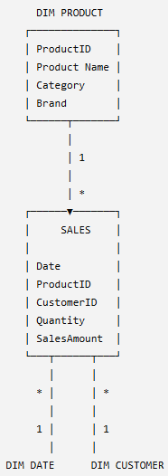

MEASURE
- A measure is a calculation that Power BI performs on your data, usually written using DAX.
For example, we have this column in our Sales fact table:
SalesAmount | - We can create: Total Sales =  SUM(Sales[SalesAmount])  - Power BI calculates: ₹200 + ₹500 + ₹300 + ₹1,000 = ₹2,000  - Measure = a dynamic calculation used to calculate business metrics/KPIs.
₹200
₹500
₹300
₹1,000
Other measures could be:  Total Quantity =  SUM(Sales[Quantity]) | Total Profit =  SUM(Sales[Profit]) | Profit Margin % =  DIVIDE(  [Total Profit],  [Total Sales]  )
- Suppose: Total Sales = ₹2,000
- Then the user selects Delhi from a slicer Power BI might automatically recalculate Delhi Total Sales = ₹1,200 Then the user selects January Delhi + January Total Sales = ₹800
- The DAX formula hasn't changed. The filter context changed, so the measure recalculated.

SEMANTIC MODEL
- A semantic model is the organized business-ready data model that Power BI uses for analysis and reporting.
- It contains things such as:
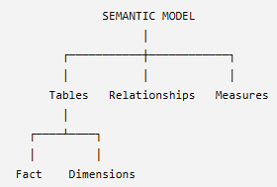 | Considering Super Market example  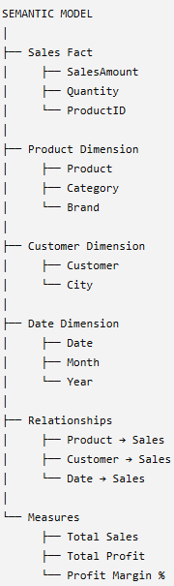
- The semantic model sits between your prepared data and your report visuals.
- For example, the report developer doesn't need to repeatedly figure out how to calculate sales. They can simply use the existing measure: [Total Sales] in a Card, Bar Chart, Matrix, etc.
- Semantic model = tables + relationships + calculations + business meaning, organized so that Power BI can analyze the data correctly.

PUTTING ALL 4 TOGETHER
Imagine the manager asks:"What were total sales by product category in January?"
Power BI uses all four concepts:
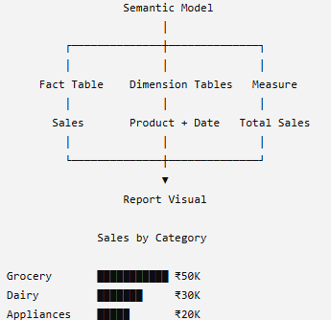

So remember these four definitions:
Term | Simple meaning | Example
Fact Table | What happened? | Sales transactions
Dimension Table | Describes what happened | Product, Customer, Date
Measure | What do I want to calculate? | Total Sales, Profit, Margin %
Semantic Model | Everything organized together for analysis | Facts + Dimensions + Relationships + Measures

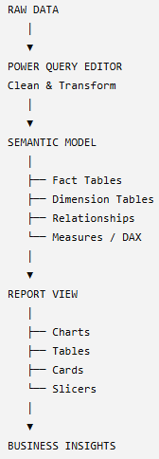 | This distinction—Power Query prepares the data, the semantic model gives the data analytical/business structure, and Report View presents the results.

MODEL VIEW — BUILD THE DATA MODEL
- The Model View defines how your tables relate to one another.
Suppose Power Query loads four tables:  Sales  Products  Customers  Calendar | In Model View, you establish relationships such as:  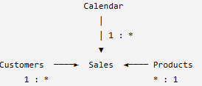
  DateKey | ProductKey | CustomerKey | Sales
  20260101 | P101 | C001 | 50,000
  ProductKey | Product
  P101 | Laptop
  CustomerKey | Customer
  C001 | ABC Ltd
  DateKey | Date | Month | Year
  20260101 | 1-Jan-26 | Jan | 2026
- Here, Sales is the fact table, while Customers, Products, and Calendar are dimension tables.
- In Model View you typically manage relationships, cardinality (1:*, 1:1, etc.), cross-filter direction, active/inactive relationships, table organization, and properties related to the semantic model.
- Model View answers: "How are my tables connected and how should the data model behave?"

DATA VIEW — UNDERSTAND DATA AND CREATE CALCULATIONS
- The Data View lets you inspect the data that has been loaded into the model in a table-like format.
- This is also where you can work with model-level calculations such as calculated columns and calculated tables.
- Measures can also be created while working in Power BI Desktop; they belong to the semantic model rather than being conceptually tied only to Data View.
- This is where DAX (Data Analysis Expressions) becomes important. For example, you could create measures such as:

Total Sales =  SUM(Sales[Sales]) | Total Profit =  SUM(Sales[Profit]) | Profit Margin % =  DIVIDE(  [Total Profit],  [Total Sales]  )
You might also create a calculated column:
Full Name =
Customer[First Name] & " " & Customer[Last Name]

The distinction between Power Query/M and DAX is especially important:
Power Query | DAX
Data preparation | Data analysis
Before/while loading data | After data is loaded into the model
Uses M language | Uses DAX language
Clean/transform data | Measures/calculated columns/tables
Merge, append, filter, reshape | SUM, CALCULATE, DIVIDE, time intelligence, etc.
- Data View helps answer: "What data is in my model, and what analytical calculations do I need?"

REPORT VIEW — BUILD THE DASHBOARD/REPORT
- Finally, the Report View is where you create what the end user actually sees.
- You take the model and measures created in the previous stages and turn them into visualizations such as bar charts, line charts, tables, matrices, cards/KPIs, maps, slicers, decomposition trees, and other interactive visuals.
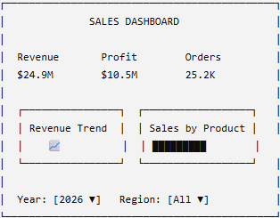 | For example, after creating:  - Total Revenue = SUM(Sales[Revenue])  - We could place [Total Revenue] into a Card visual.  - Then combine that with other visuals:  The Report View therefore handles the presentation and interaction layer: visuals, formatting, filters, slicers, drill-through, tooltips, bookmarks, navigation, and report pages.  So:

PUTTING THE ENTIRE POWER BI WORKFLOW TOGETHER
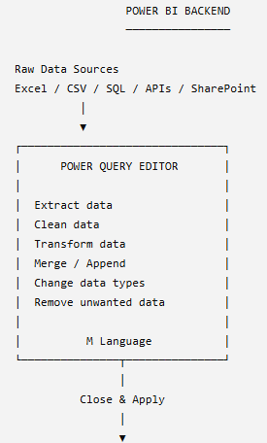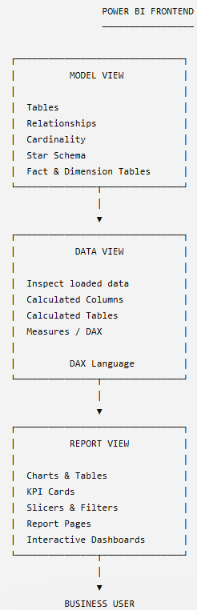 | - Power BI starts with the Power Query Editor, which acts as the backend data-preparation layer where we connect to data sources and perform ETL transformations using Power Query/M.  - Once the data is loaded, the frontend consists of the Model View, where we define relationships and the semantic model;  - The Data View, where we inspect the loaded data and create DAX-based calculations;  - The Report View, where we use that model and those measures to build interactive reports and visualizations.
  Component | Main purpose | Think of it as
  Power Query Editor | Clean & transform raw data | Data preparation
  Model View | Connect and organize tables | Data architecture
  Data View | Inspect data & create calculations | Data analysis / DAX
  Report View | Build visuals and reports | Data presentation

STORAGE AND CONNECTION MODES
- In Power BI, storage/connection mode tells Power BI where the data lives and how Power BI retrieves it when a user interacts with a report.
- The main modes to understand are
  - Import
  - DirectQuery
  - Live Connection as a related connection approach.
  - Composite Model, where different tables can use different modes.

IMPORT MODE
- In Import mode, Power BI connects to the source, retrieves the data, and loads a compressed copy into the Power BI semantic model.
- The dataset must be in less than 1GB after compression
- The tables are stored in memory with Power BI and queries are fulfilled by cached data
- Import datasets are useful when we need fast query performance.
- Useful when source data does not changes frequently
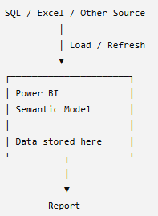 | Suppose SQL Server contains:  - Power BI imports a copy of those records.  - When you create: Total Sales =  SUM(Sales[Sales])  - Power BI calculates against the imported data, rather than sending a SQL query back to the source every time you click a visual.  - That's why Import mode is generally very fast for report interaction.  - However, imagine someone inserts another ₹10,000 sale into the SQL database at 2 PM.  - Power BI won't automatically know about it just because the source changed. The imported model needs to be refreshed to bring in the latest source data.  - Import = Bring the data into Power BI → very fast analysis → refresh required for source changes
  Product | Sales
  Laptop | ₹50,000
  Mobile | ₹30,000
  TV | ₹40,000

DIRECTQUERY
With DirectQuery, Power BI generally does not import the full table data into the semantic model.
Instead, the data remains in the underlying source.
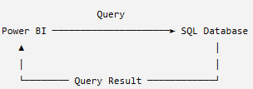 | - Directly connects Power BI to the source data without importing the entire dataset into Power BI.  - Queries are sent to the source system and executed on demand whenever data is required.  - Commonly used when:  - The dataset is too large to efficiently import and store in memory.  - Source data changes frequently and reports need access to up-to-date data.  - For example – Use case when Company/security policies cannot be importing or copying data into Power BI.  - Data must remain in and be accessed from the original source system.  - Key idea:  Data stays at the source → Power BI sends queries to the source → Source processes the query → Results are returned to Power BI.

LIVE CONNECTION

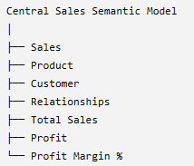 | - Imagine another team has already created a centralized Power BI semantic model:  - You don't necessarily want to recreate everything.  - Instead, your Power BI report can connect to that existing semantic model.  - The report uses the centralized model's tables, relationships, measures, and security/business logic.  - This is useful in enterprise environments because many reports can reuse the same governed semantic model.  - Example  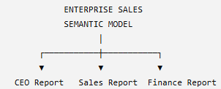
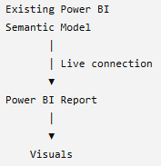

Instead of each report developer independently recreating:
Total Revenue
Total Profit
Profit Margin
the organization can define these measures centrally.
So:
Live connection = Build a report on an existing Analysis Services/Power BI semantic model rather than creating an independent imported model from the original raw source.
Modern Power BI also supports extending some connections to existing Power BI semantic models through composite-model capabilities, so "live connection" shouldn't be treated as meaning that the report can never have local modeling. q

COMPOSITE MODEL
- You don't necessarily have to choose one mode for everything.
- A semantic model can combine storage approaches.
For example:
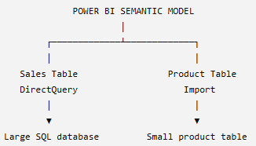
Suppose:
- Sales = 500 million rows and changes frequently
- Product = 10,000 rows and changes rarely
You might keep Sales in DirectQuery, while importing Product for faster access.
This creates a Composite Model.
Composite Model = A semantic model that combines different storage/connection approaches.

EXTRACTING DATA FROM WEB
- The Web Connector allows Power BI to retrieve data from websites and web-hosted files(csv,xlsx etc.).
- Power BI can scan a webpage, identify structured tables, and make them available for import.
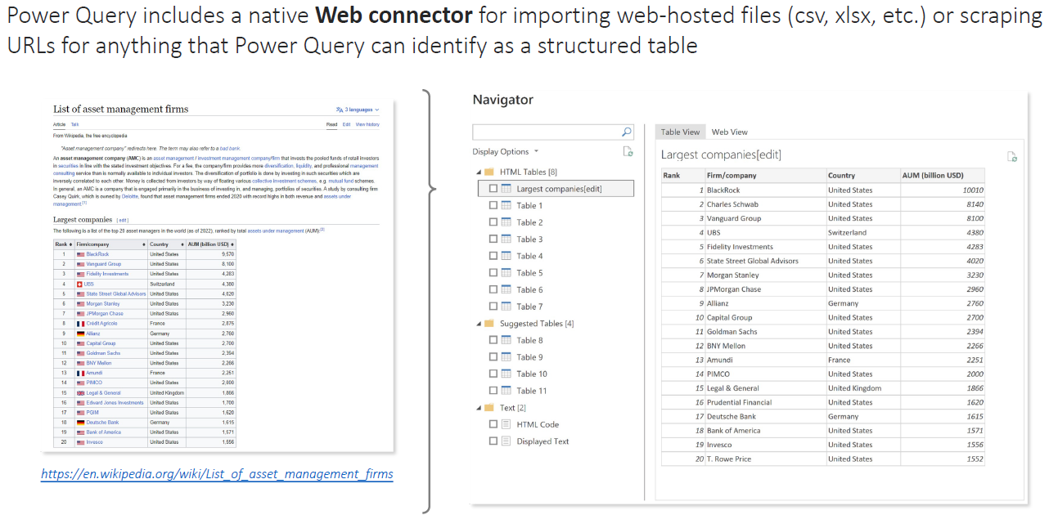
Website to scrap : https://en.wikipedia.org/wiki/List_of_asset_management_firms
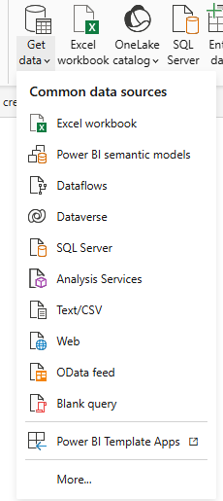 | 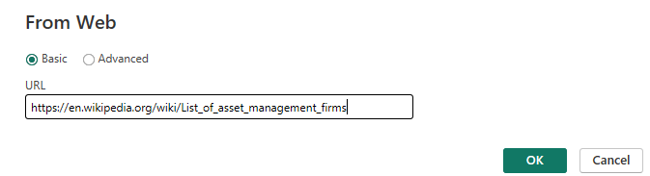  - To connect to a webpage:  - Go to New Source → Web.  - Copy and paste the webpage URL.  - Choose Basic connection and click OK.  DATA PREVIEW  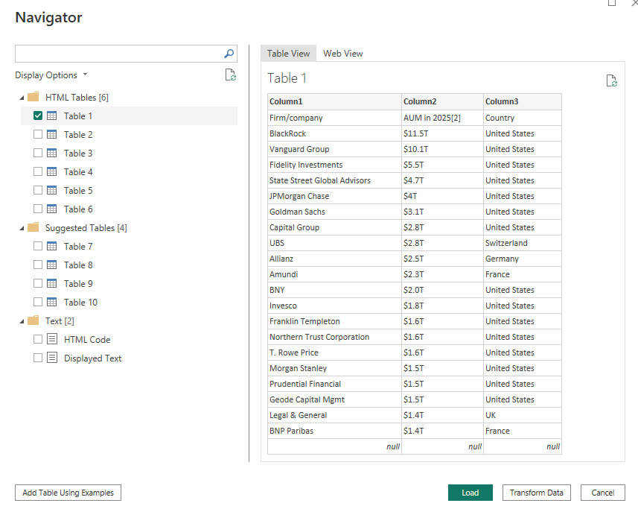
- After connecting, Power BI opens the Navigator/Data Preview window.
- Power BI displays the different tables/elements detected on the webpage.
- Selecting a table shows a preview of its data.
- Web View lets you view the actual webpage, making it easier to identify which webpage table corresponds to the detected table.
- You can select the required table(s) and load/transform them in Power Query Editor.
- Once in Power Query, the data can be cleaned and transformed like any other data source:
  - Check and correct column headers.
  - Verify data types such as Text, Whole Number, and Currency.
  - Apply additional transformations if required.
  - Give the query a meaningful name.
- Key takeaway: Webpage URL → Web Connector → Detect Tables → Preview/Select Table → Power Query → Clean & Transform → Load Data.

DATA QA AND PROFILLING TOOL IN POWER QUERY EDITOR
- Data profiling means examining your data before using it in your Power BI model/report to understand its quality, structure, and potential problems.(Think of it as a health check for your data.)
- Suppose Power Query contains this customer data:
 | Before loading this data, we want to know:  - Are there errors?  - Are there blank/null values?  - How many different values exist?  - Are there unexpected duplicates?  - What are the minimum and maximum values?  - Which values occur most frequently?
  Row | Customer |  | Age | City
  1 | Amit |  | 25 | Delhi
  2 | Priya |  | 32 | Mumbai
  3 | Rahul |  | 25 | Delhi
  4 | Neha |  | 40 | Kolkata
  5 | Arjun |  | 25 | Delhi
  6 | Riya |  | Error | Mumbai
  7 | Karan |  | 32
  8 | Pooja |  | 28 | Delhi
  9 | Sameer |  | 35 | Mumbai
  10 | Anjali |  | 30 | Delhi

Power Query provides three main profiling tools for this:
- COLUMN QUALITY
- COLUMN DISTRIBUTION
- COLUMN PROFILE
- Profiling tools allow you to explore the quality, composition, and distribution of your data before loading it into the Power BI front-end

COLUMN QUALITY
- Column Quality tells you whether the values in a column are Valid, Error, or Empty.
- Column Quality shows the percentage of values in each column that are:
Category | Meaning
Valid | Value is acceptable for the column's data type
Error | Power Query encountered an error for that value
Empty | Value is null/missing
- Example: Customer Age
Valid: 92% | Error: 3% | Empty: 5%
- This immediately tells you that 8% of the column may need attention.
- Column Quality is especially useful for quickly identifying errors and missing values without manually scanning thousands of rows.
- Hovering over the Column Quality information provides additional details and contextual options. These contextual menus can provide quick data-cleaning actions such as:  - Remove duplicates  - Remove empty values  - Remove errors  - Replace errors  - Other cleanup operations | 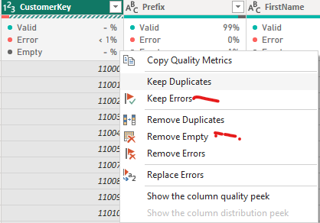

- Key concept: Column Quality = a quick health check of a column showing Valid, Error, and Empty values and providing options to clean identified issues.
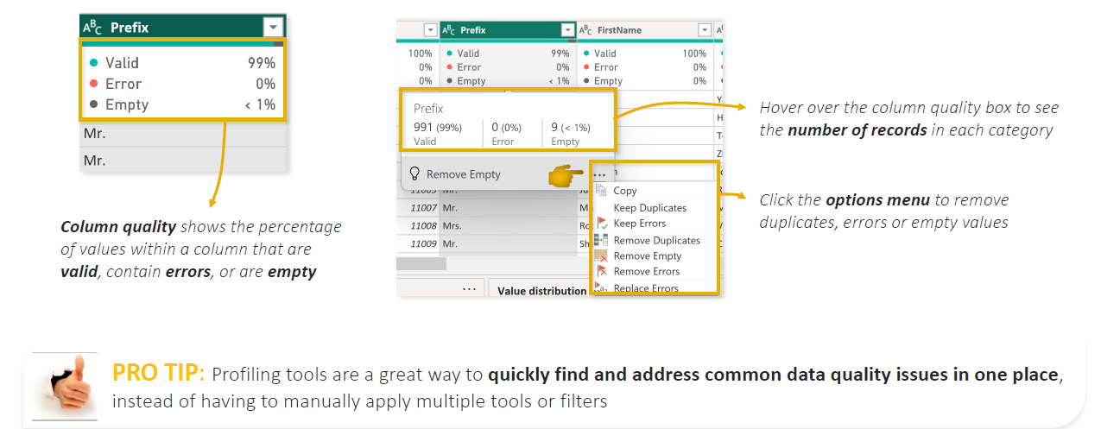
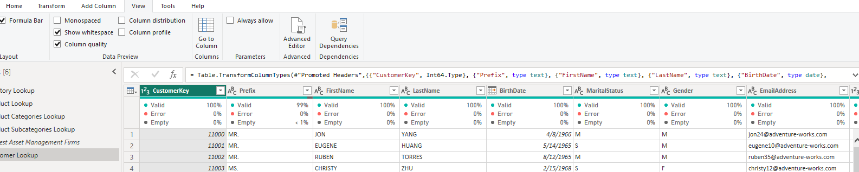
Note – initially the profile shows the report based on top 1000 records, to update and get column quality profile data
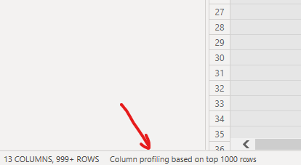

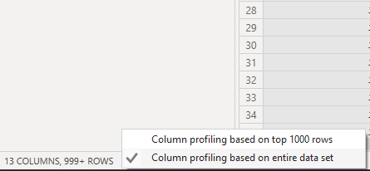

COLUMN DISTRIBUTION
- Column Distribution answers a different question:"How are the values in this column distributed?"
- It shows information such as:
- Distinct values
- Unique values
- Frequency/distribution of values
This introduces two important terms.
DISTINCT VS UNIQUE
- Distinct = number of different values.
Unique = number of values that occur exactly once.
Suppose the City column contains:  - Delhi  - Mumbai  - Delhi  - Kolkata  - Delhi  - Mumbai  - Chennai  Unique values : Values that appear exactly once:  - Kolkata → appears once  - Chennai → appears once  Therefore: Unique = 2 | Distinct values means - Different values that exist:  - Delhi  - Mumbai  - Kolkata  - Chennai  Distinct = 4  Even though Delhi appears three times, it is counted only once

Another example  Suppose:  Age  ---  25,25,25,32,32,28,35,40  Distinct = 5  Unique = 3 | The distribution is: | The visual distribution might look roughly like:  25 ███████████████ 3  32 ██████████ 2  28 █████ 1  35 █████ 1  40 █████ 1
  Age | Frequency
  25 | 3
  32 | 2
  28 | 1
  35 | 1
  40 | 1
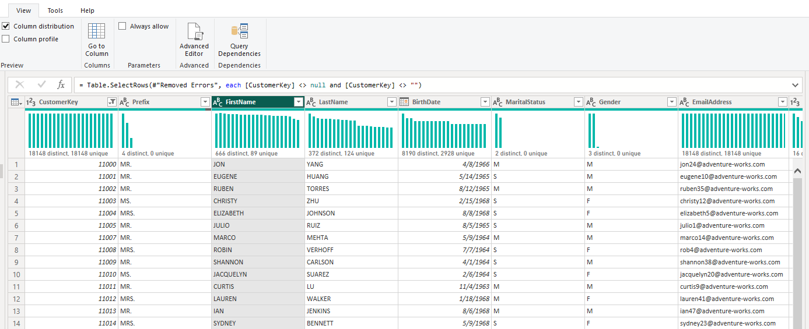
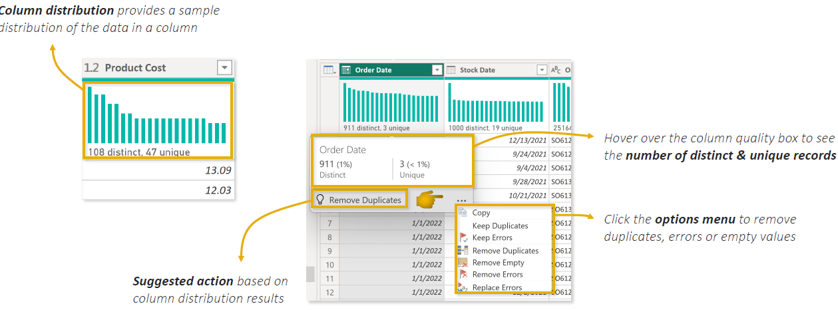

COLUMN PROFILE
- Column Profile is the most detailed of the three tools.
- It provides a more complete analysis of a selected column. It is detailed report card for one column.
- It combines information about the column with additional statistics.
- For example, select the Age column.
Power Query could show:  Column Statistics  - Count 10 Total number of values/records considered in the column.  - Error 1 Number of error values.  - Empty 0 Number of missing/null values.  - Distinct 7  - Unique 5  - Min 25  - Max 40 | the Value Distribution:  25 ███████████  32 ███████  28 ███  30 ███  35 ███  40 ███
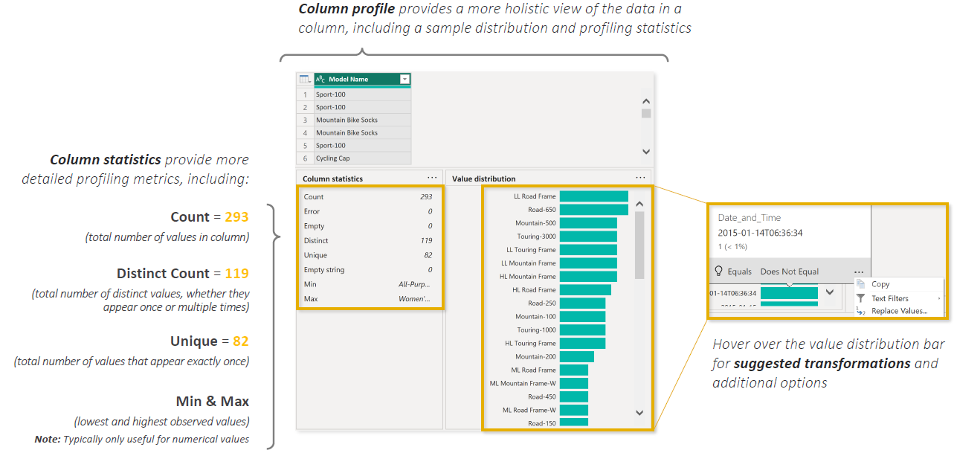

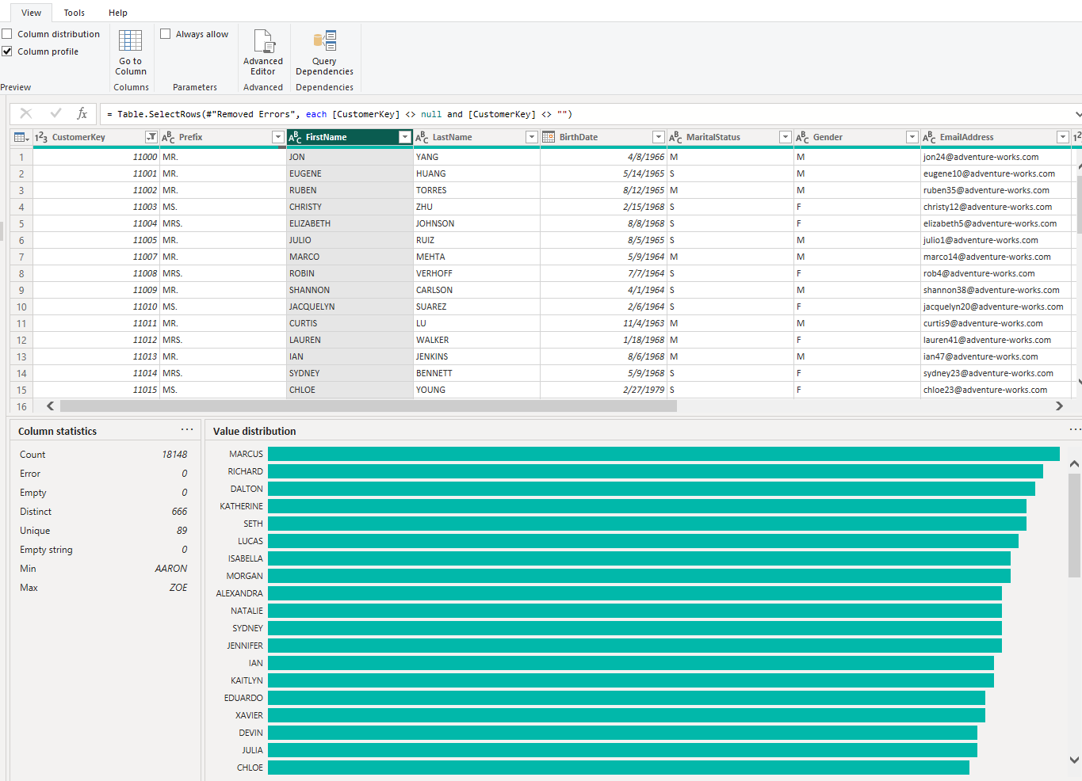

TEXT TOOLS
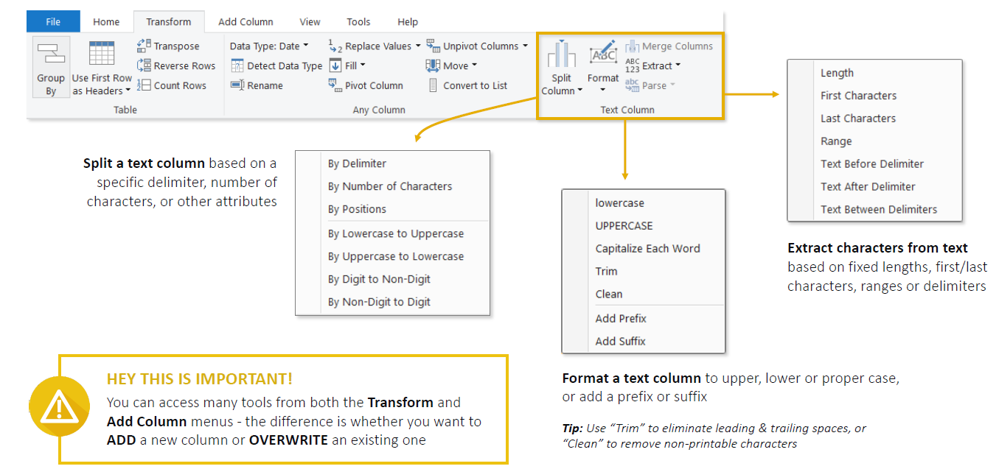
- Text-specific tools are available in the Power Query Editor, mainly under the Transform and Add Column tabs.
- They are used to clean, format, split, combine, and extract information from text columns.
SPLIT COLUMN  - Used to divide one text column into multiple columns.  - A column can be split based on:  - A delimiter such as -, ,, /, or space.  - A specific number of characters. | Example:  CustomerID = INDIA-10025  Split using -: “-” delimiter
  Country | ID
  INDIA | 10025
FORMAT TEXT  Power Query provides several formatting options:  - lowercase: NEW YORK → new york  - UPPERCASE: india → INDIA  - Capitalize Each Word / Proper Case: john smith → John Smith  - Trim: removes leading and trailing spaces.  - Clean: removes non-printable/control characters. | Trim is especially important. For example:  "India"  "India "  They look identical to us, but the second value contains a trailing space. Power BI may therefore treat them as two different values.  Using Trim standardizes them:  "India"  "India "  ↓  "India"  "India"
EXTRACT TOOLS  Extract allows you to take only a particular part of a text string.  You can extract:  - First characters  - Last characters  - A specific range of characters  - Text before a delimiter  - Text after a delimiter  - Text between delimiters | For example:  EmployeeID = INDIA-MUMBAI-10025  Before delimiter -:INDIA  After a chosen delimiter:MUMBAI-10025  Between delimiters:MUMBAI  Advanced options also let you control things such as whether Power Query searches from the start or end of the string and which occurrence of a delimiter should be used.
MERGE COLUMNS  - Merge Columns combines multiple columns into one.  - You need to select multiple columns before this option becomes available. | For example:  Merge with a space: Rahul Sharma
  First Name | Last Name
  Rahul | Sharma

DATE AND TIME TOOL
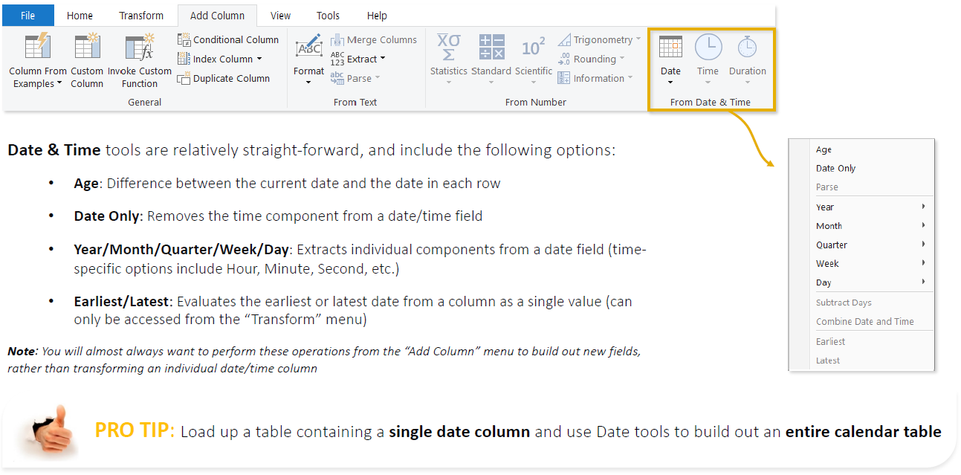

INDEX AND CONDITIONAL COLUMN
Both are available in Power Query Editor → Add Column, but they serve very different purposes.

INDEX COLUMN

An Index Column adds a sequential number to each row(Think of it as adding a row number) | Suppose your data is: | After adding an Index:
  Product | Sales
  Laptop | 50,000
  Mobile | 30,000
  TV | 40,000
  Index | Product | Sales
  1 | Laptop | 50,000
  2 | Mobile | 30,000
  3 | TV | 40,000
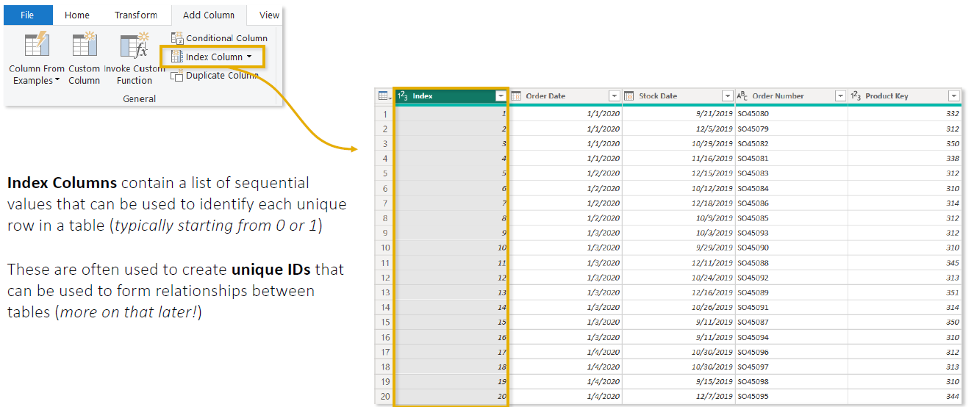
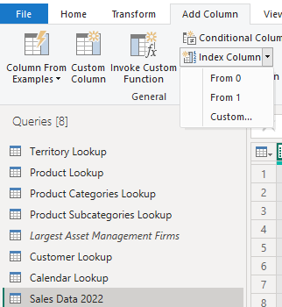 | Adding Index Column:Go to:Power Query Editor → Add Column → Index Column  You can choose:  - From 0 → 0, 1, 2, 3...  - From 1 → 1, 2, 3, 4...  - Custom → choose your own starting number and increment.  For example, custom settings:  - Start = 100, Increment = 10  - Produces:100, 110, 120, 130...  Why use an Index Column?  It is useful for:  - Adding row numbers  - Creating a simple sequential identifier  - Preserving/working with a particular row order  - Supporting transformations that need previous/next-row logic  - Creating ranking-like sequences after sorting data

CONDITIONAL COLUMN
- A Conditional Column creates a new column based on IF/THEN logic. IF this condition is true → return this value; otherwise → return another value.
 | We want a new column:  - Sales ≥ 100,000 → High  - Sales ≥ 50,000 → Medium  - Otherwise → Low | After adding a Conditional Column:
  Employee | Sales
  Amit | 120,000
  Rahul | 75,000
  Priya | 40,000
  Employee | Sales | Sales Category
  Amit | 120,000 | High
  Rahul | 75,000 | Medium
  Priya | 40,000 | Low
- How to create it - Go to: Power Query Editor → Add Column → Conditional Column
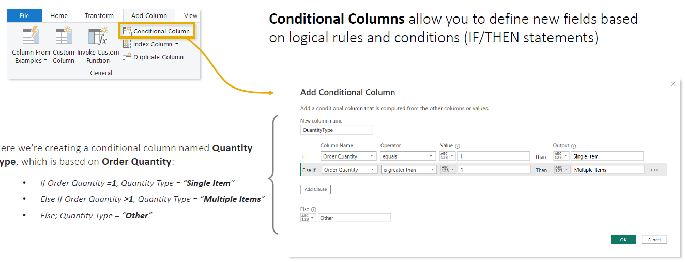

CALCULATED COLUMN BEST PRACTICES

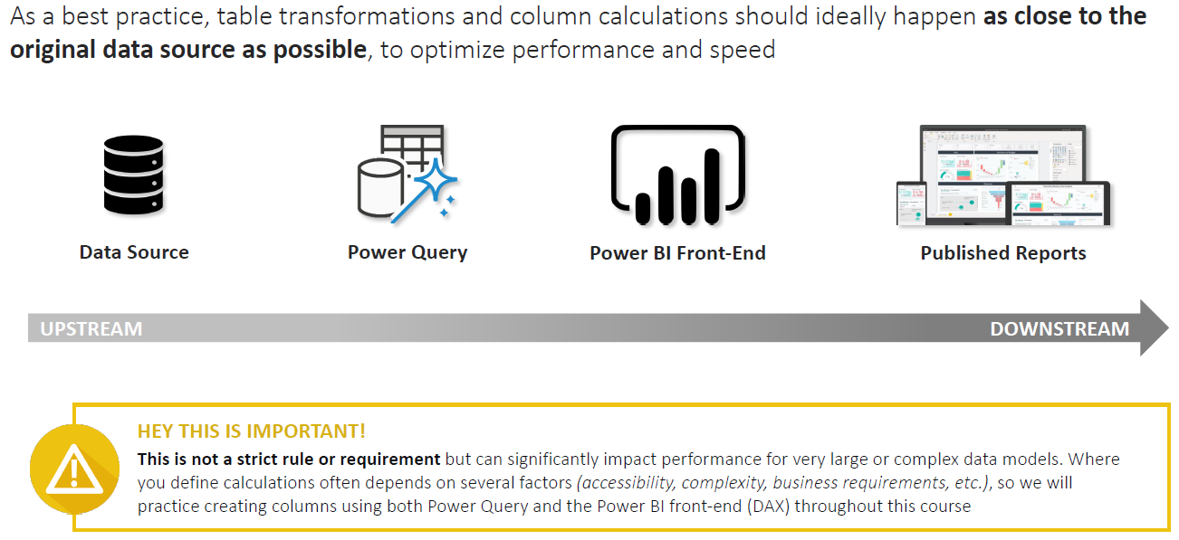
- Think about calculated column best practices like deciding where the work should be done.
- Suppose your company has employee data:
First Name | Last Name | Salary
Rahul | Sharma | 50,000
Priya | Singh | 70,000
- You want to create a new column:Full Name = First Name + Last Name
There are several places where you could create it.
Option 1 — Create it in the Data Source ⭐ Best if practical
- If the data comes from SQL Server, you could ask SQL Server to provide:
First Name | Last Name | Full Name | Salary
Rahul | Sharma | Rahul Sharma | 50,000
Priya | Singh | Priya Singh | 70,000
- Now Power BI doesn't have to create Full Name. It simply receives it.
- Think of it like ordering food from a restaurant:
- It's better if the kitchen prepares the food before sending it to your table, rather than giving you ingredients and asking you to prepare it yourself.
- The database is designed to process data, so if the transformation can sensibly happen there, let the source do the work.
Option 2 — Create it in Power Query ⭐ Next choice
- Sometimes you cannot modify the source database.
- Maybe you don't have permission to change SQL or the source is an Excel file you don't control.
- Then use Power Query:
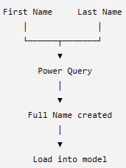
Power Query prepares the column before the final data is loaded into the Power BI model.
This is why Power Query is an excellent place for things like:
- Combining columns
- Splitting columns
- Cleaning text
- Replacing values
- Conditional columns
- Removing unnecessary columns
- Other row-by-row data preparation

Option 3 — Create a DAX Calculated Column in Power BI
You can also load the original data first and then create:
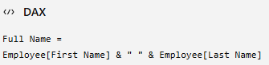
This works perfectly.But now the new column is being created inside the Power BI semantic model.
Why does this matter from performance prespective?
- Power BI Import mode uses an engine called VertiPaq.
- VertiPaq takes your data and tries to compress and organize it efficiently in memory so your reports can run quickly.
- Imagine you're loading: 50 million sales records, If you unnecessarily create lots of additional calculated columns inside the model, those columns also have to be stored and can make the model larger.
For example:
Original Model(500 MB) + Several unnecessary calculated columns Larger modelMore memory usagePotentially slower / less efficient

GROUPING AND AGGREGATION

GROUP BY – BASIC
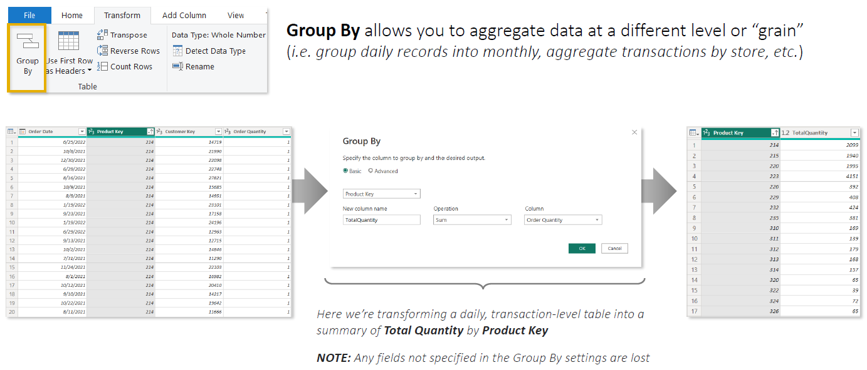

GROUP BY – ADVANCED
- The advanced option give a flexibility to group by multiple columns
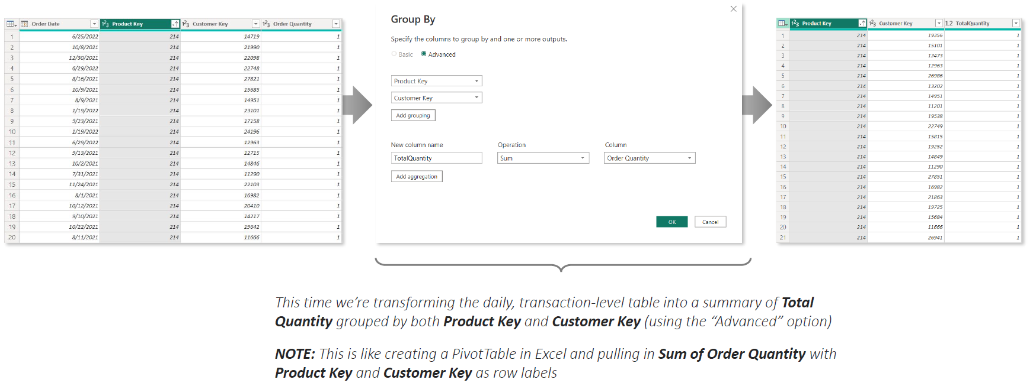

PIVOTING AND UNPIVOTING

MERGING AND APPENDING QUERIES
- Both Merge and Append are used in Power Query Editor to combine data from multiple tables, but they combine data in completely different ways.
    - Merge = Add COLUMNS → combine side by side
    - Append = Add ROWS → stack one table below another

MERGE QUERIES(TABLE JOINS)
Merge Queries combines two tables horizontally by matching a common column/key.
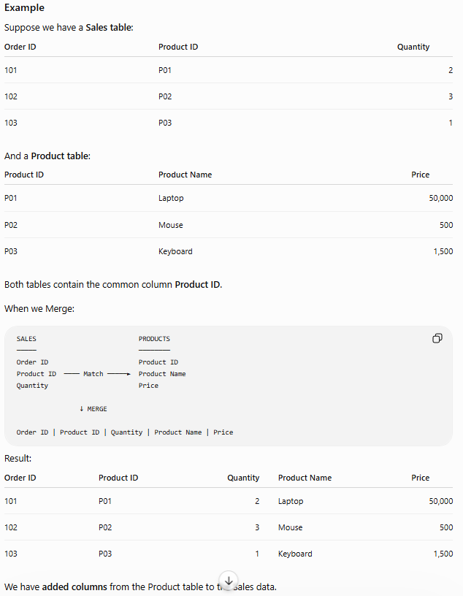
How to do it
Power Query Editor → Home → Merge Queries
Then:
- Select the first table.
- Select the second table.
- Select the matching column(s).
- Choose the Join Type.
- Click OK.
- Expand the resulting column to select the fields you want.
Common Join Types
Join | Meaning
Left Outer | All rows from first table + matching rows from second
Right Outer | All rows from second + matching rows from first
Inner | Only rows that match in both
Full Outer | All rows from both tables
Left Anti | Rows in first table that don't exist in second
Right Anti | Rows in second table that don't exist in first
Left Outer is one of the most commonly used.

MERGE QUERIES VS MERGE QUERIES AS NEW

MERGE QUERIES  - Performs the merge inside the currently selected query.  - It does not create a separate merged query.  - After the merge, you can expand the matched columns into your current table. | MERGE QUERIES AS NEW  - Leaves both original queries unchanged.  - Creates a third, new query containing the merged result.  Merge Queries as New = Keep my original queries + create a separate query containing the merged result
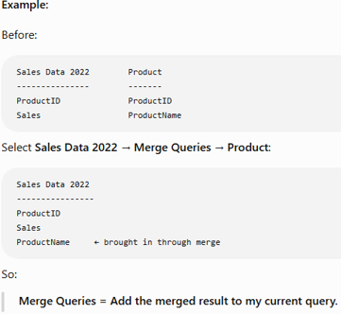 | 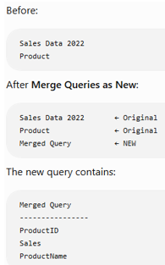

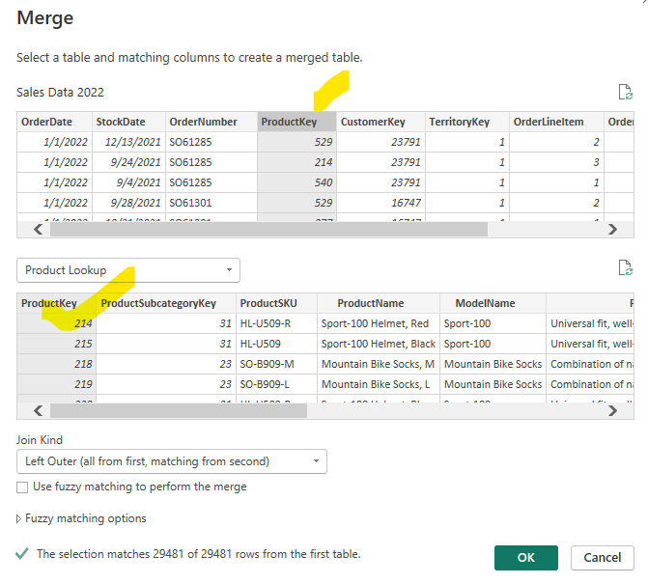
- Select the main table: Example: Sales Data 2022.
- Go to Home → Merge Queries.
- Select the second table: Example: Product Lookup.
- Select the common/key column in both tables.
  - Sales[Product Key] ↔ Product Lookup[Product Key].
- Choose the Join Type: Usually Left Outer: keep all Sales rows and bring matching Product information Click OK.
- A new Table column appears in the Sales table.
- Click the Expand (⇔) button on that column.
- Select only the columns you need, e.g.:
  - Product Name
  - Product Color
- Click OK → the selected columns are added to the Sales table.
Result:
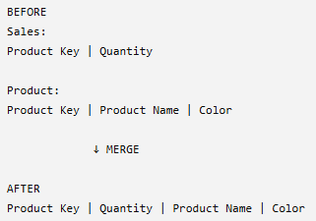
Key Points
- Merge = adds COLUMNS, not rows.
- Don't merge just because you can. In Power BI models, keeping Fact and Dimension tables separate and creating relationships is often preferable because unnecessary merges can create duplicated/redundant data.
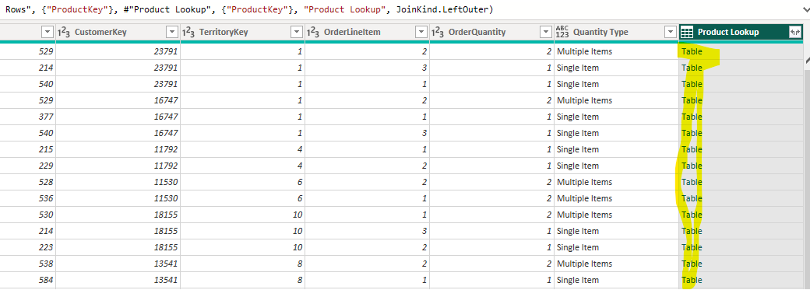

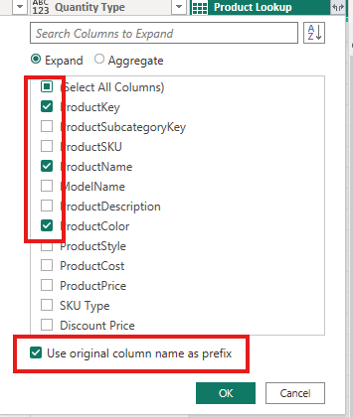
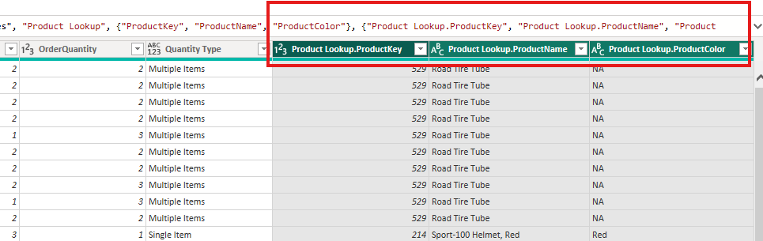

APPEND QUERIES
- Append combines tables vertically by placing the rows of one table underneath another.
- It is similar to UNION ALL in SQL, where Same type of data from different places/periods → put everything into one table.
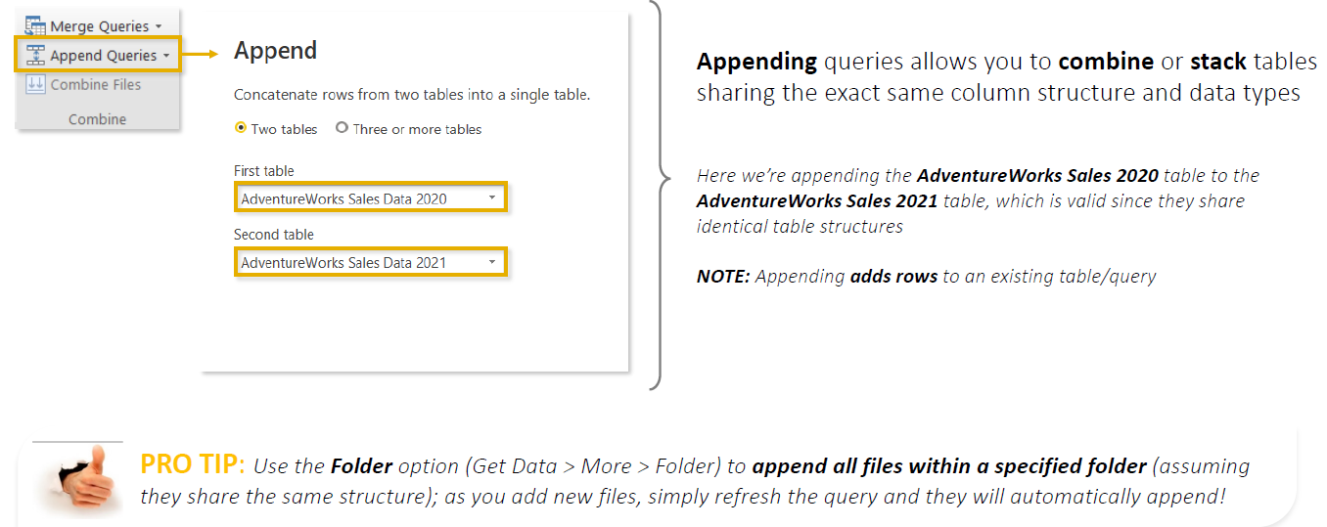
- Append Queries combines multiple tables by stacking their rows into one table.
- Append is commonly used when you have the same type of data in separate files/tables, such as:
  - Sales 2020
  - Sales 2021
  - Sales 2022
→ combined into one Sales 2020–2022 table.
- For the best results, tables should have:
  - Same column names/structure
  - Compatible data types
  - Same meaning for corresponding columns
- Go to Power Query Editor → Home → Append Queries.
- You can append:
  - Two tables
  - Three or more tables
- There are two options:
  - Append Queries → appends data into the currently selected query.
  - Append Queries as New → creates a new combined query while keeping the original queries.
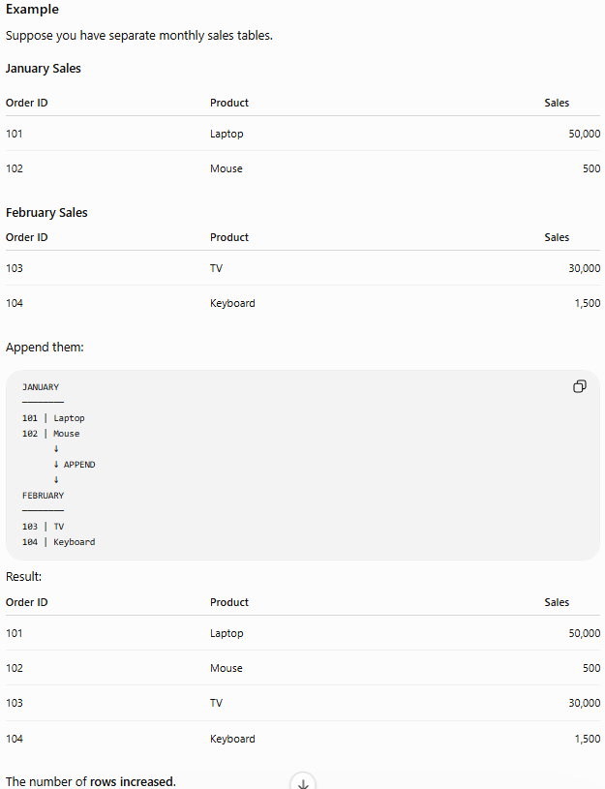
What if Append Tables Have Different Columns?
- If one table has a column that the others don't, Power Query can still append them, but the missing values will appear as null.

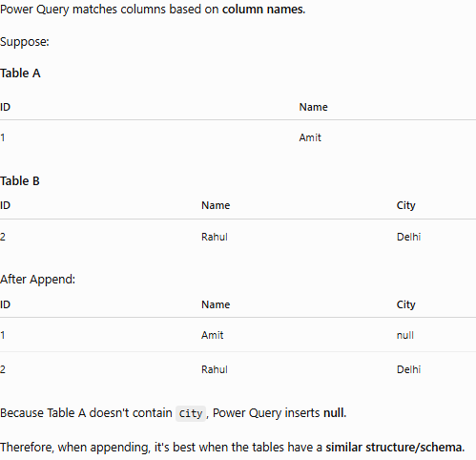
- In below example – we use Append Query As New
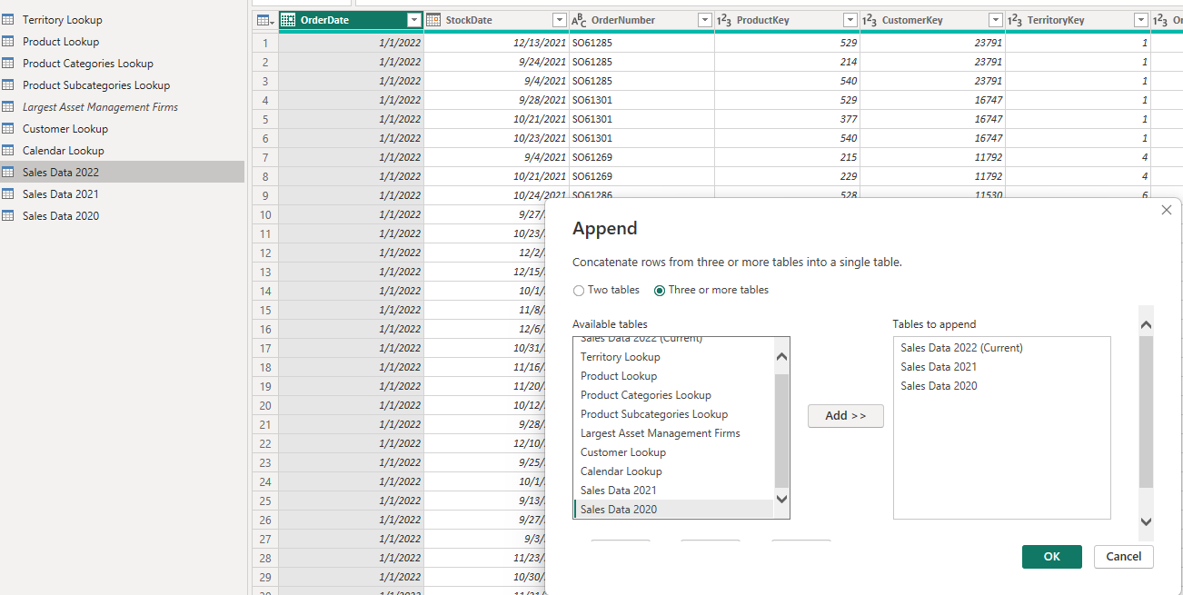

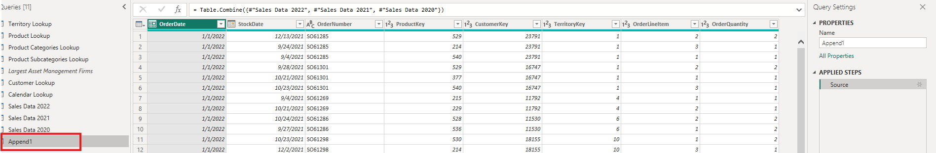
Note : With Append Queries as New, the new combined query depends on the original queries, due to this dependencies we cannot delete the source queries.
WHY CAN’T WE DELETE THE ORIGINAL TABLES AFTER APPEND?
Suppose you have:
Sales 2020 ──┐
Sales 2021 ──┼──→ Sales 2020–2022
Sales 2022 ──┘
- When you use Append Queries as New, Power Query creates a new query that references the three original queries.
- The combined Sales 2020–2022 query is therefore dependent on Sales 2020, Sales 2021, and Sales 2022.
- If you try to delete one of the original queries, Power BI warns you because the appended query needs it to produce its result.
- This means you end up maintaining 4 queries:
  - Sales 2020
  - Sales 2021
  - Sales 2022
  - Sales 2020–2022
- The Better Approach — Folder Connector
Connecting to a Folder in Power BI — Short Steps
Purpose: Combine multiple files with the same structure automatically instead of manually appending them.
- Put similar files in one folder
  - Sales 2020.csv
  - Sales 2021.csv
  - Sales 2022.csv
- In Power Query Editor, go to New Source → More → Folder.
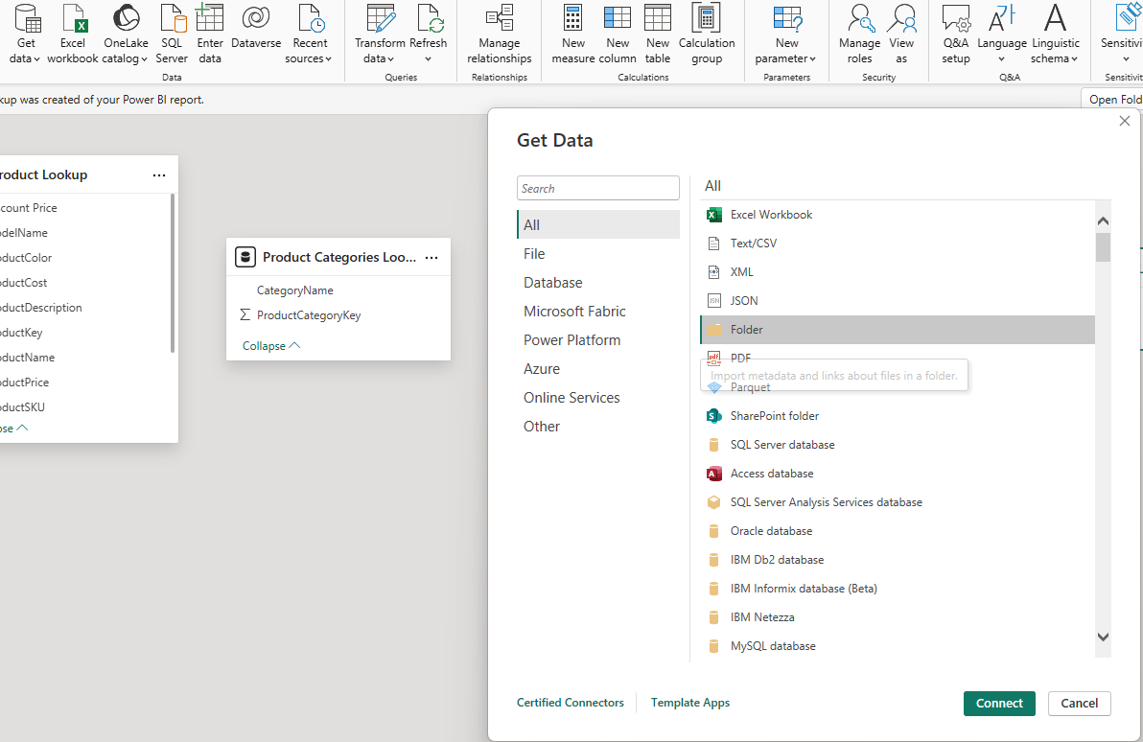
- Browse and select the folder containing the sales files.
- Power BI shows a preview of the files in the folder rather than their actual data.
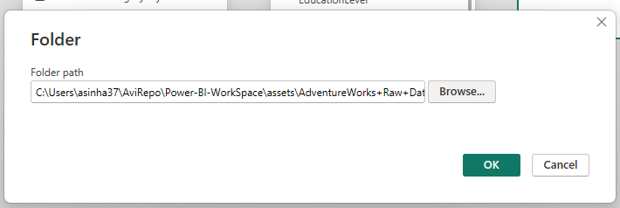
- Click Transform Data.
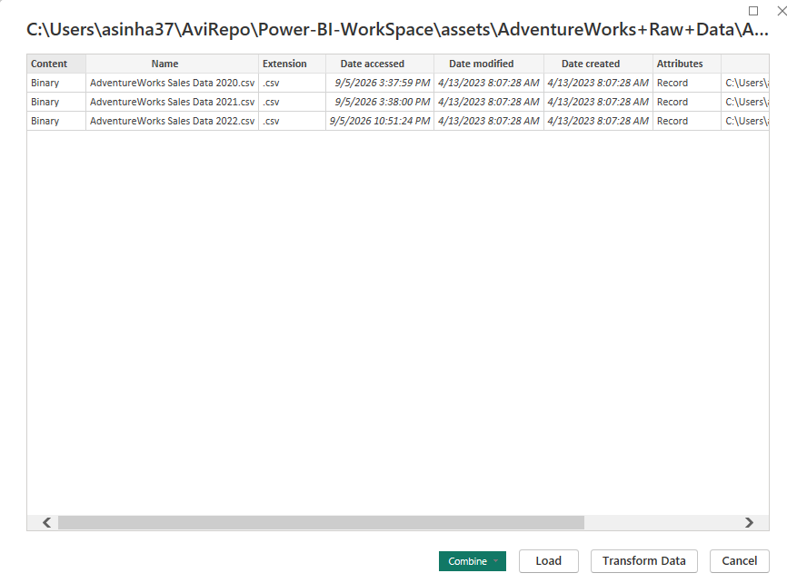
- In the Content column, click Combine Files.
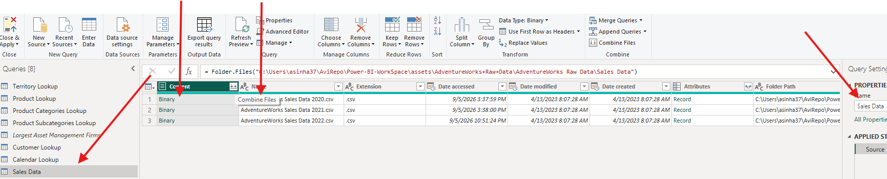
- Power BI uses a sample file to determine how the files should be combined.
  - Verify column names.
  - Verify structure/data looks correct.
- Click OK → Power BI automatically appends/stacks all files.
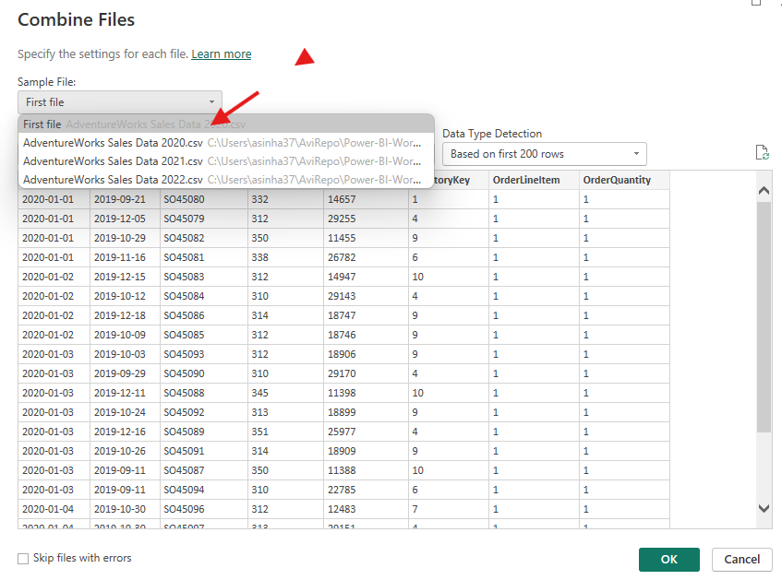
- Check the resulting combined data:
  - 2020
  - 2021
  - 2022
should now all appear in one Sales table.
- Power BI may create a Source Name column showing which file each row came from. Keep it if useful; otherwise remove it.
- Power BI automatically creates some helper queries and transformation steps behind the scenes. These can normally just be collapsed.
- Click Close & Apply to load the final combined table.
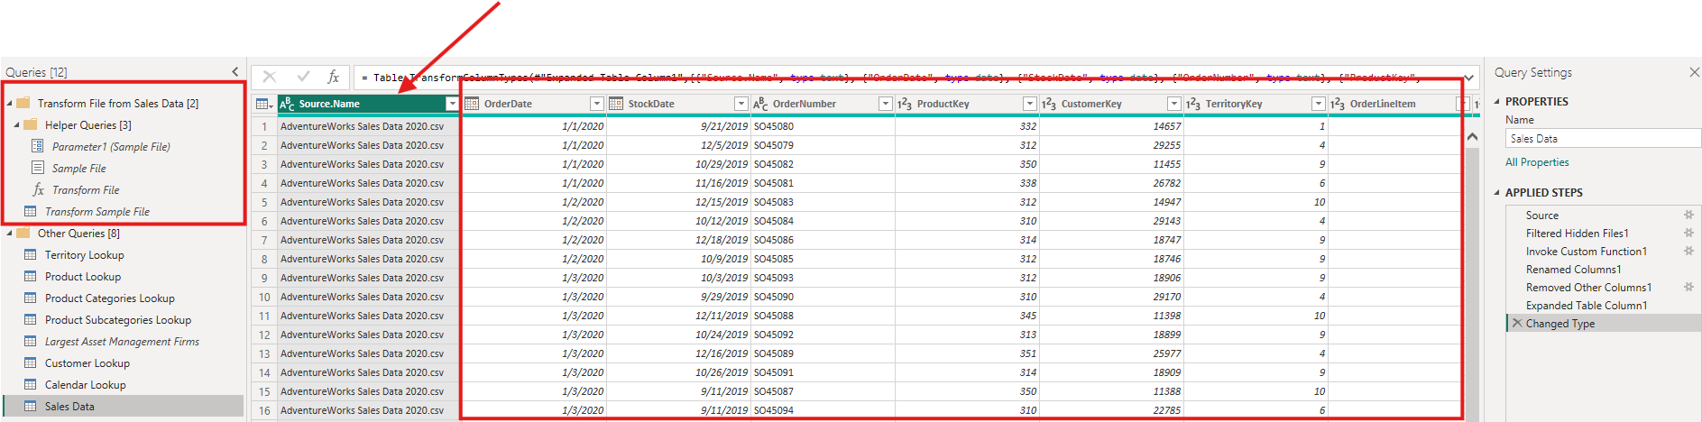
- The Main Advantage is If later you receive: Sales 2023.csv
simply place it in the same folder:
📁 Sales Data
├── Sales 2020.csv
├── Sales 2021.csv
├── Sales 2022.csv
└── Sales 2023.csv ← NEW
- Then Refresh Power BI → the new file's data is automatically included.
- Key takeaway: For recurring files with the same structure, Folder Connector + Combine Files is more scalable and easier to maintain than manually appending each file.

DATA-SOURCE SETTINGS
- When importing data files, such as CSV files, Power BI may show a data source error if the file path changes or the file is renamed.
- To fix such issues – we have multiple ways
METHOD 1
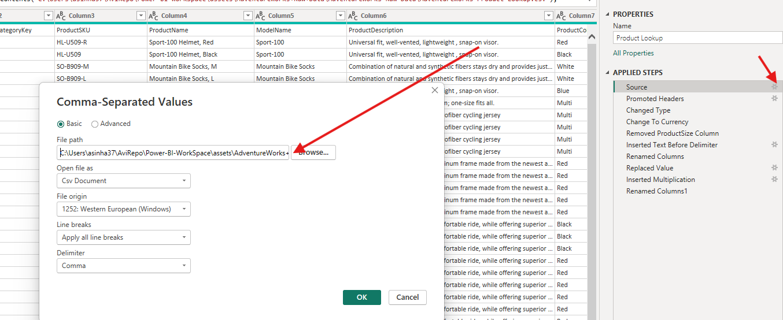
METHOD 2
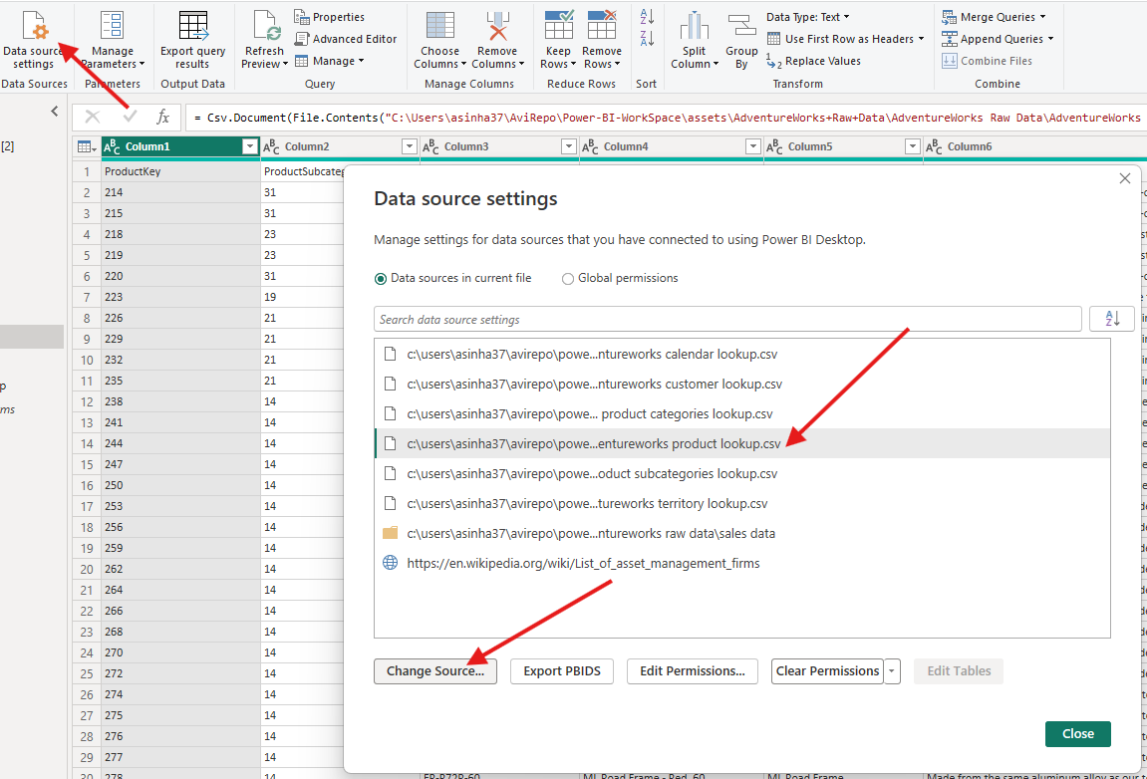

- Note: After changing the path make sure to click to “Refresh”
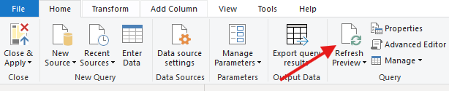

REFRESH QUERIES
- Query Refresh means asking Power BI to go back to the data source and retrieve the latest data for your queries/tables.
- For example, suppose your Power BI report uses:
  - Sales Data
  - Product Lookup
  - Customer Lookup
  - Territory Lookup
  - Calendar
- Today your Sales Data contains 100,000 transactions. Tomorrow, 5,000 new transactions are added to the source.
- When you click Home → Refresh, Power BI refreshes the relevant queries so the model can receive the latest source data.

What Happens by Default?
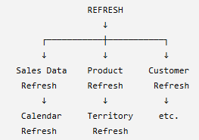 | By default, clicking Refresh in Power BI refreshes the model's included data connections/queries.  But some of these tables may rarely or never change.  For example:  - Product Lookup → static  - Territory Lookup → static  - Calendar → static  - Sales Data → changes every day  Refreshing everything unnecessarily can increase refresh time.
Controlling Which Queries Refresh
In Power Query Editor:
- Find the table/query in the Queries pane.
- Right-click the query.
- Find Include in report refresh.
- Uncheck it if the query doesn't need to refresh.
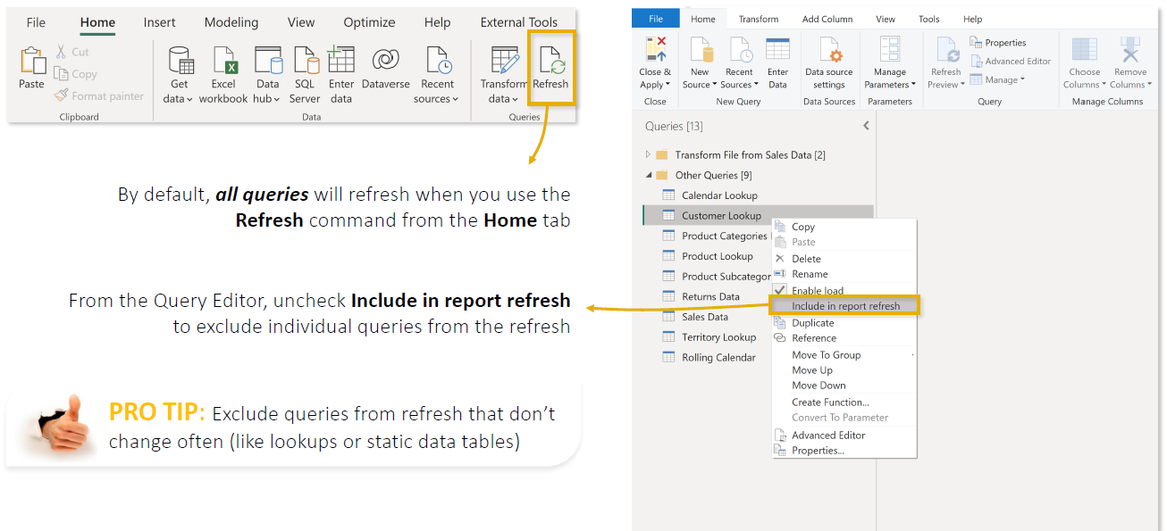
Key Points from the Lecture
- Refresh retrieves updated data from your sources.
- By default, relevant queries are generally included in report refresh.
- You can control individual queries through Power Query → Right-click query → Include in report refresh.
- If a table is static and truly doesn't need to change, you can consider excluding it from refresh.
- Frequently changing tables, such as Sales/Transactions, normally remain included.
- Reducing unnecessary refresh work can improve refresh time and efficiency.
- Enable Load and Include in Report Refresh serve different purposes.

CREATING DATA MODEL
- In a data model, the tables(queries) are connected via relationship based on common field, these help Power BI to understands how the data is connected and can analyze it correctly.
- Data modeling is mainly performed in Model View of Power BI.
- Tables are commonly organized into:
  - Fact Tables → contain transactions/numbers to analyze, e.g., Sales.
  - Dimension Tables → contain descriptive information, e.g., Product, Customer, Date.
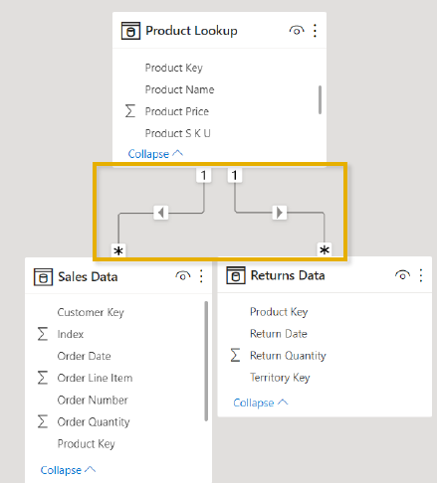 | - Tables are connected using common keys.  - Example: Sales[ProductID] ↔Product[ProductID]  - Relationships have cardinality, such as:  - One-to-Many (1:*) — most common  - One-to-One (1:1)  - Many-to-Many (:)  - A Star Schema is generally preferred:  Dimension Tables → Fact Table ← Dimension Tables  - A good data model makes it easier to:  - Filter and analyze data correctly.  - Create DAX measures such as Total Sales and Profit.  - Build accurate reports and visuals.  - Improve model usability and performance.

NORMALIZATION
- Data normalization is the process of organizing data into separate, related tables to reduce duplicate/redundant data and improve data consistency.
- Normalization = Don't store the same information repeatedly. Separate it into logical tables and connect them using keys.
- Example
Suppose we have one large Sales table:
Order ID | Product ID | Product Name | Category | Price | Qty
101 | P01 | Laptop | Electronics | 50,000 | 1
102 | P01 | Laptop | Electronics | 50,000 | 2
103 | P01 | Laptop | Electronics | 50,000 | 1
104 | P02 | Mouse | Electronics | 500 | 3
Notice that:Laptop → Electronics → ₹50,000 is repeated again and again.This is redundant data.
After Normalization
We separate the information into two tables.
Sales Table | Product Table
  Order ID | Product ID | Qty
  101 | P01 | 1
  102 | P01 | 2
  103 | P01 | 1
  104 | P02 | 3
  Product ID | Product Name | Category | Price
  P01 | Laptop | Electronics | 50,000
  P02 | Mouse | Electronics | 500
Then connect them using Product ID:
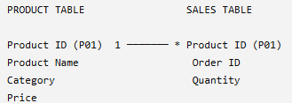
Now Laptop, Electronics, and ₹50,000 only need to be stored once in the Product table.
Key Points
- Reduces duplicate/repeated data
- Divides large tables into smaller logical tables
- Tables are connected using Primary Keys and Foreign Keys
- Improves data consistency and integrity
- Makes source/database data easier to maintain
In Power BI
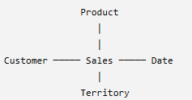  STAR SCHEMA | There's an important distinction: highly normalized designs are common in source databases, but for analytical Power BI models, we often prefer a simpler Star Schema:  - Normalization = separate data to reduce redundancy.  - Star Schema = organize analytical data into Fact and Dimension tables for easier and efficient reporting.

FACTS & DIMENSION TABLES
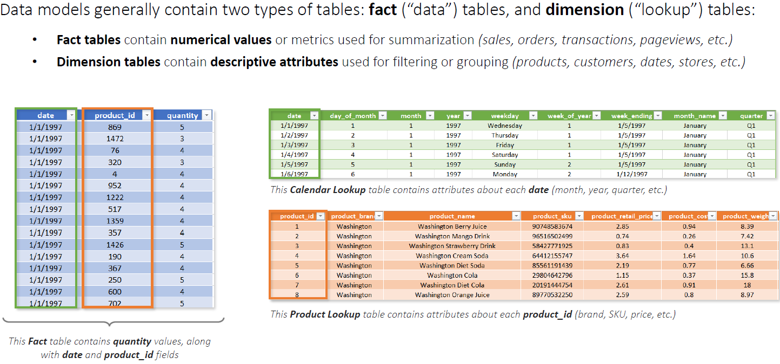
Let's use a simple supermarket sales example.

FACT TABLE — DATA TABLE
A Fact Table contains the transactions or events that happened in the business, along with the numerical values we want to analyze.
For example, every time a customer buys something, a transaction is recorded in the Sales fact table.
Sales Fact Table
Order ID | Date ID | Product ID | Customer ID | Quantity | Sales Amount
1001 | D01 | P01 | C01 | 2 | ₹2,000
1002 | D01 | P02 | C02 | 1 | ₹500
1003 | D02 | P01 | C03 | 3 | ₹3,000
1004 | D02 | P03 | C01 | 1 | ₹5,000
Each row represents a sales transaction.
The Fact Table contains two important types of columns:
Keys, which connect to other tables:
- Product ID
- Customer ID
- Date ID
Numeric facts, which we analyze:
- Quantity
- Sales Amount
- Cost
- Discount
- Profit
- Fact Table = Business transactions/events + keys + values to analyze.

DIMENSION TABLE — LOOKUP TABLE
- A Dimension Table contains descriptive information about the data in the Fact Table.
- It tells us more about the Product, Customer, Date, Location, etc.
- That's why you'll sometimes hear them called Lookup Tables.
- For example, the Sales table contains:
  - Product ID = P01
  - But what exactly is P01?
- The Product Dimension tells us.
Product Dimension
Product ID | Product Name | Category | Brand
P01 | Laptop | Electronics | Dell
P02 | Mouse | Accessories | Logitech
P03 | TV | Electronics | Samsung
Now Power BI knows:P01 → Laptop → Electronics → Dell
Customer Dimension
The Fact Table also contains Customer IDs:
Customer ID | Customer Name | City | Country
C01 | Amit | Delhi | India
C02 | Priya | Mumbai | India
C03 | Rahul | Kolkata | India
So:
C01 → Amit → Delhi → India
Date Dimension
Date ID | Date | Month | Quarter | Year
D01 | 01-Jan-26 | January | Q1 | 2026
D02 | 02-Jan-26 | January | Q1 | 2026
This lets us analyze sales by:
- Day
- Month
- Quarter
- Year

HOW FACT AND DIMENSION TABLES WORK TOGETHER?
We connect the Dimension Tables to the Fact Table using keys. The fact and dimension table shares a common key
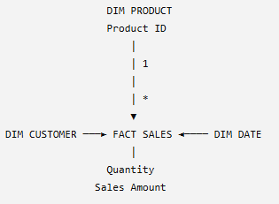 | 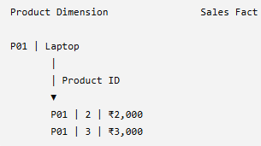

SHARED DIMENSION TABLE
- A Shared Dimension is a Dimension/Lookup table that has relationships with multiple Fact tables.
- For example:
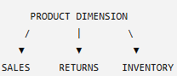
- Here, Product is a shared dimension because the same Product table can filter all three Fact tables.
Why Are Shared Dimensions Useful in Reports?
Shared dimensions allow us to analyze and compare measures from multiple Fact tables using the same field.
For example:
- Sales Fact → Sales Quantity
- Returns Fact → Return Quantity
- Inventory Fact → Stock Quantity
- Product Dimension → Product Name
Because Product is shared, we can create:
Product | Sales Qty | Return Qty | Stock Qty
Laptop | 1,000 | 50 | 200
Mobile | 800 | 30 | 150
TV | 500 | 20 | 100
- When the report filters Product = Laptop, that Product filter flows to all three Fact tables, so Power BI calculates Laptop's Sales, Returns, and Inventory together.
Other Examples
- If Date is shared between Sales and Returns: We can compare Sales vs Returns by Month.
- If Territory is shared: We can compare Sales vs Returns by Country/Region.
Key Points
- Shared Dimension = one Dimension connected to multiple Fact tables.
- It provides a common way to filter/group multiple Facts.
- It allows measures from different Fact tables to be placed together meaningfully in the same report visual.
- Fact tables generally don't need to connect directly; shared dimensions provide the common analytical path.
- A dimension can only filter Facts for which a valid relationship/filter path exists.
In simple terms: A shared dimension acts as a common filter between multiple Fact tables, allowing us to compare different business metrics—such as Sales, Returns, and Inventory—by the same Product, Date, Territory, etc.

PRIMARY AND FOREIGN KEYS
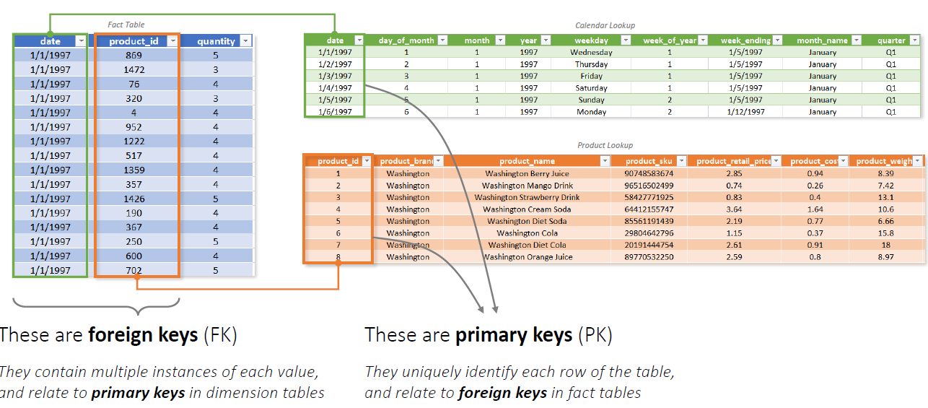

ASSIGNING PRIMARY KEY TO A COLUMN
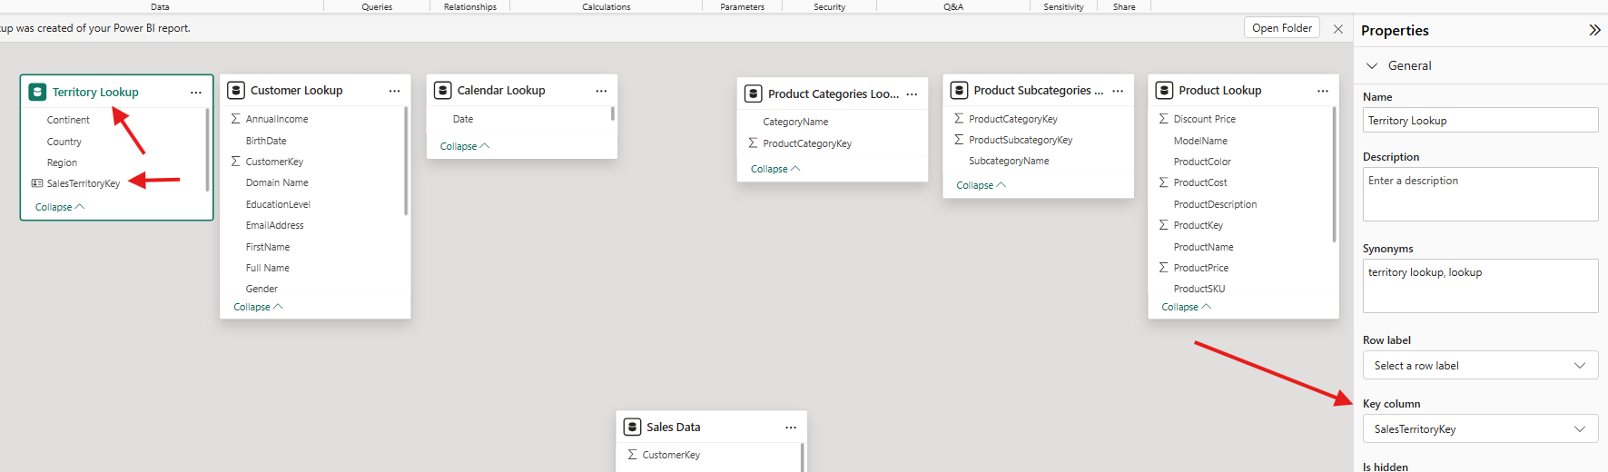

MODEL VIEW
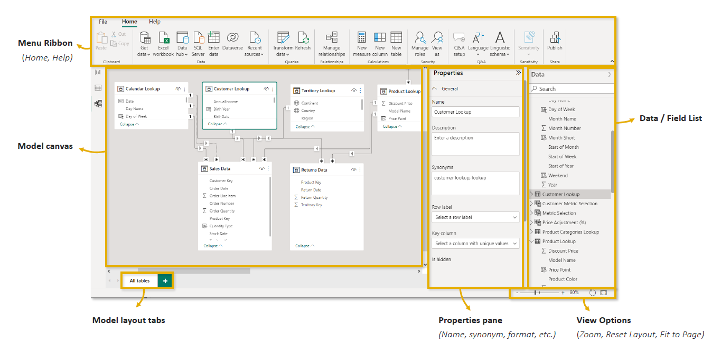

CREATING RELATIONSHIP
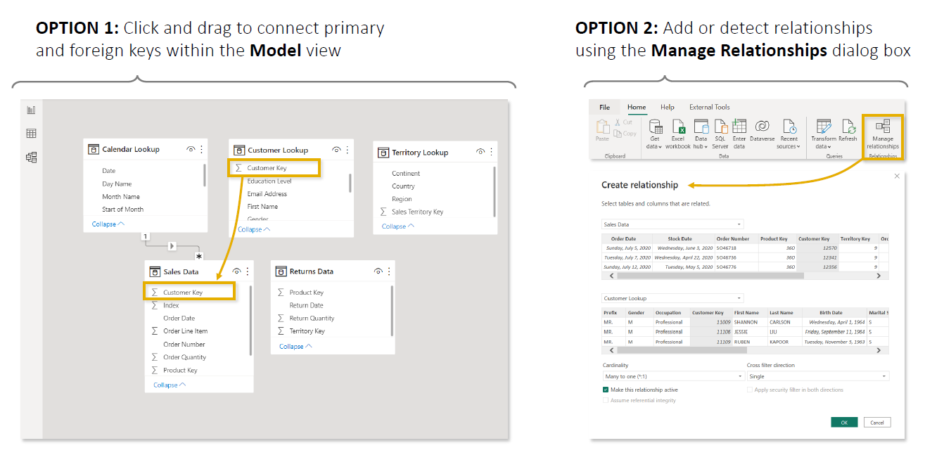

OPTION 1- DRAG AND DROP
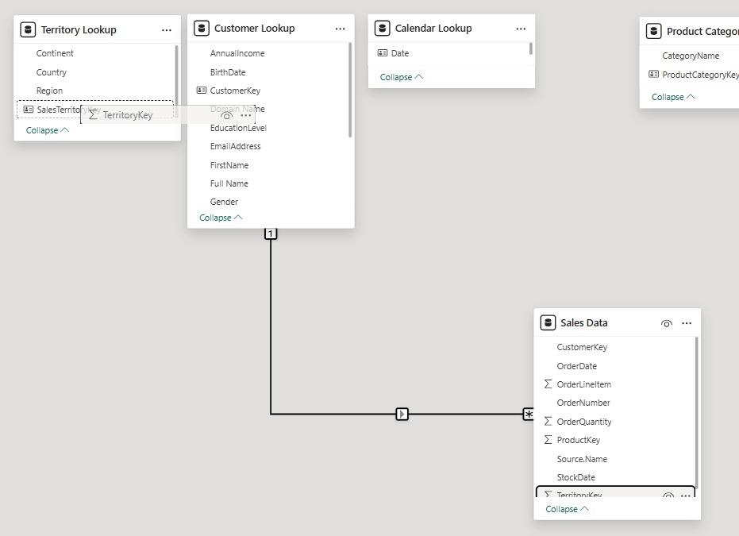

OPTION 2
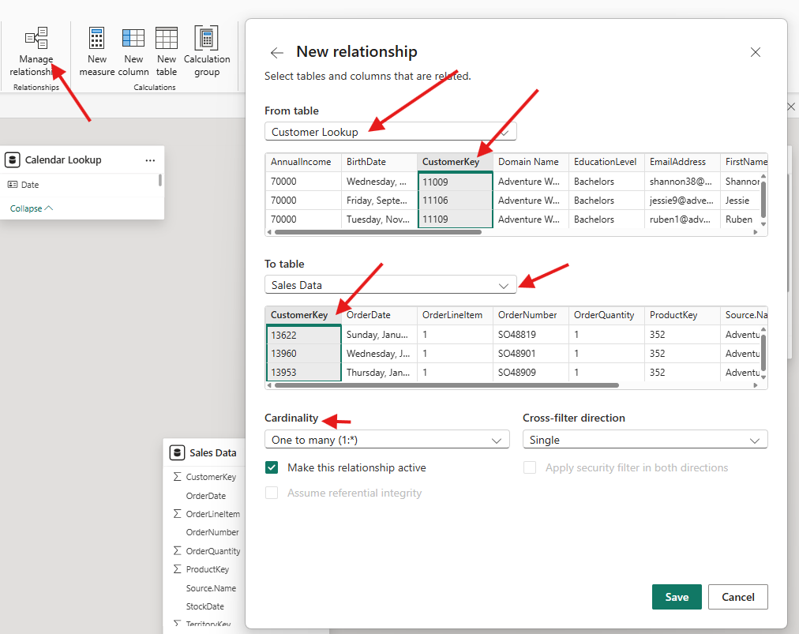
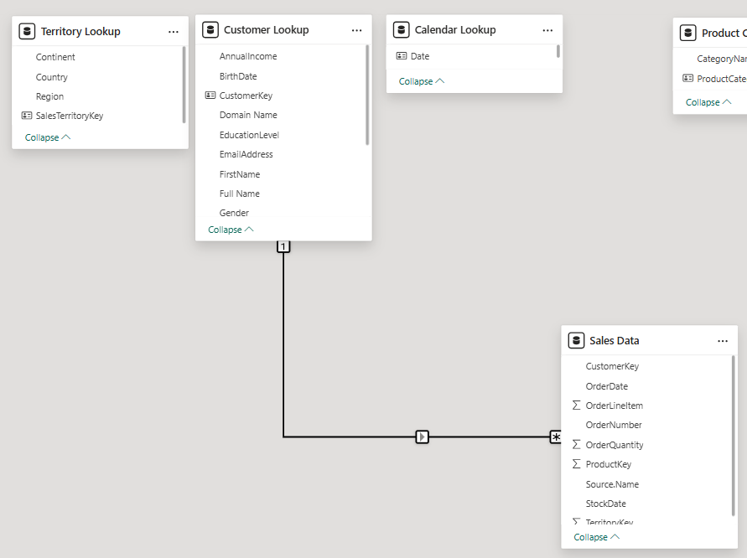

EDITING RELATIONSHIP
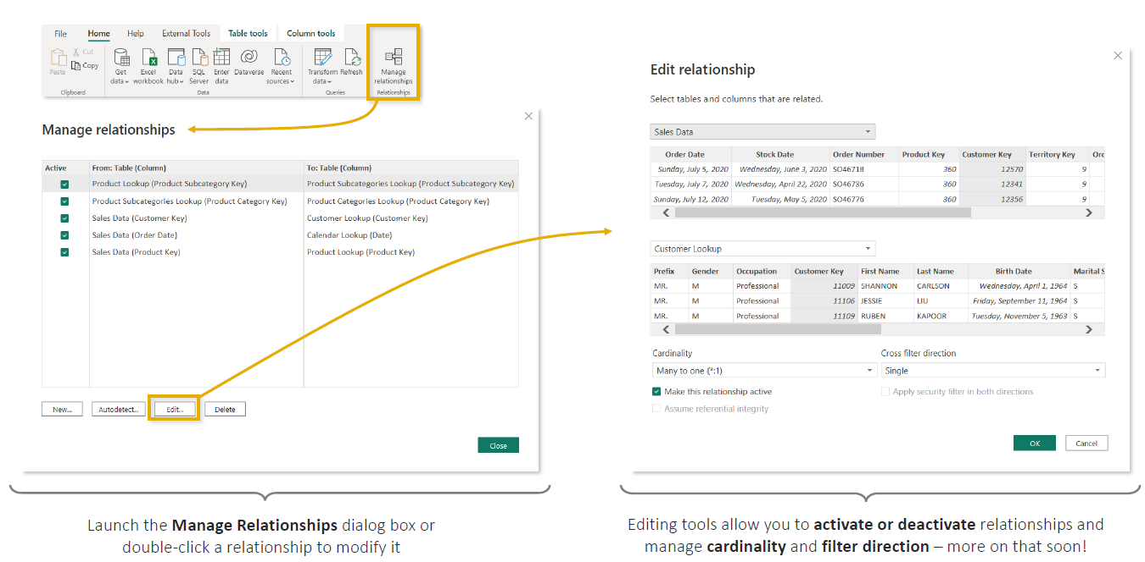

ACTIVE & INACTIVE RELATIONSHIP
- A relationship connects two tables using common columns. In Power BI, a relationship can be either Active or Inactive.
- There can be only one active relationship between tables at a time.

ACTIVE RELATIONSHIP
- An active relationship is the relationship Power BI uses automatically when filtering and calculating data.
- In Model View, it appears as a solid line.
- Example: suppose the Sales table contains two dates:
Sales Data(Fact Table) | Date – (Dimension Table) | Relation - We could create two relationships
 |  | 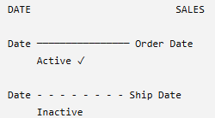
  Order ID | Order Date | Ship Date | Sales
  101 | 1-Jan | 3-Jan | ₹10,000
  102 | 2-Jan | 5-Jan | ₹20,000
  Date | Month | Year
  1-Jan | January | 2026
  2-Jan | January | 2026
  3-Jan | January | 2026
- If the relationship between Date[Date] and Sales[Order Date] is active, then when you create a report showing: Sales by Month : Power BI automatically interprets that as: “Calculate sales according to Order Date."
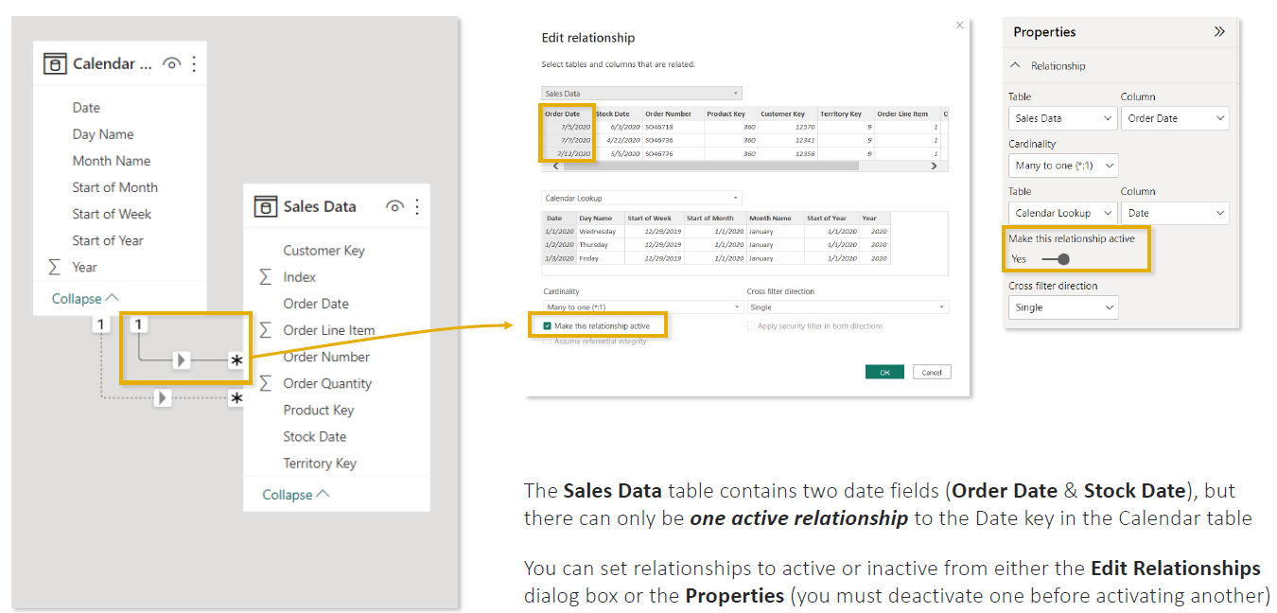

INACTIVE RELATIONSHIP
- An inactive relationship exists in the model, but Power BI does not use it automatically for normal filter propagation.
- In Model View, it appears as a dashed line.
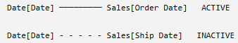
Why have an inactive relationship?
Because sometimes you need multiple relationships between the same two tables.
Here, both are logically valid:
- Date → Order Date
- Date → Ship Date
But Power BI needs an unambiguous default filtering path, so one can be active while the other remains inactive.
Key point: An inactive relationship isn't a bad or broken relationship. It's a valid relationship that Power BI doesn't use by default, but you can use it for specific calculations (in DAX Query) when needed.
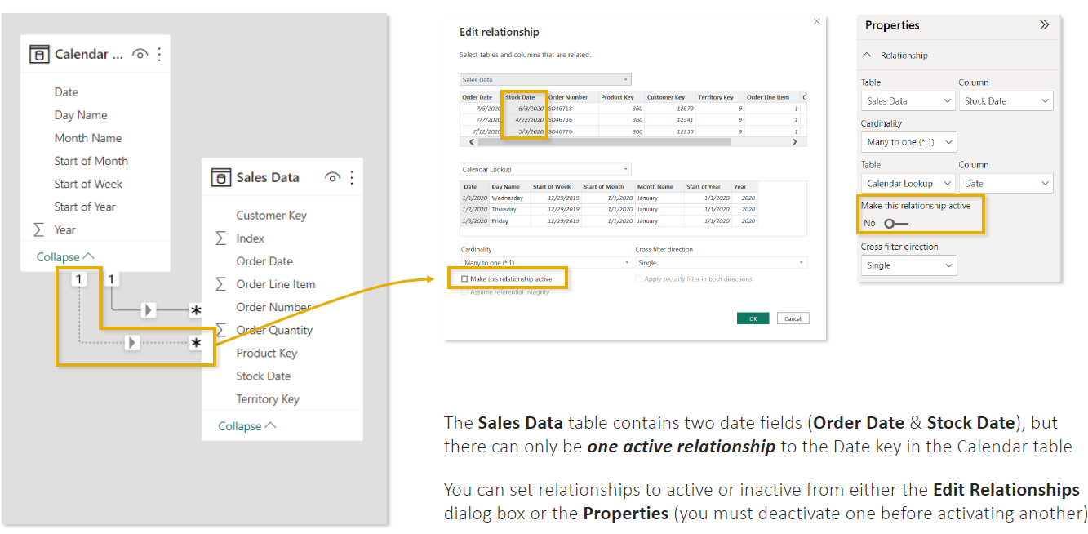

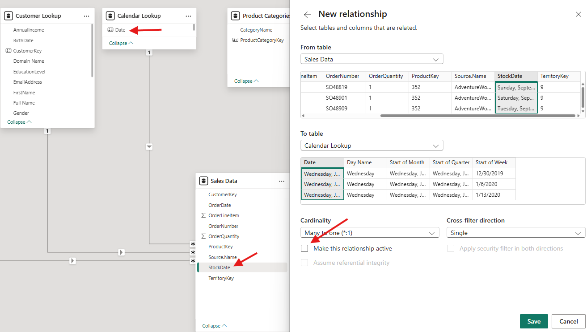

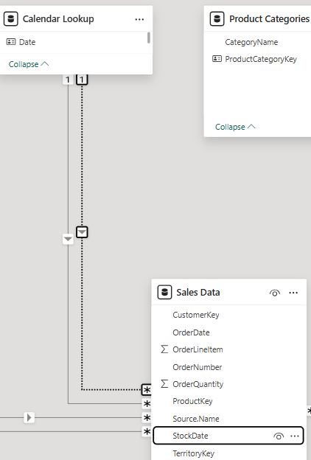
How to Change Active/Inactive
- Go to Model View.
- Select or double-click the relationship.
- Open Edit Relationship, or use the Properties pane.
- Turn Make this relationship active on/off.
- If another conflicting relationship is already active, deactivate it first.
- Activate the relationship you want Power BI to use by default.
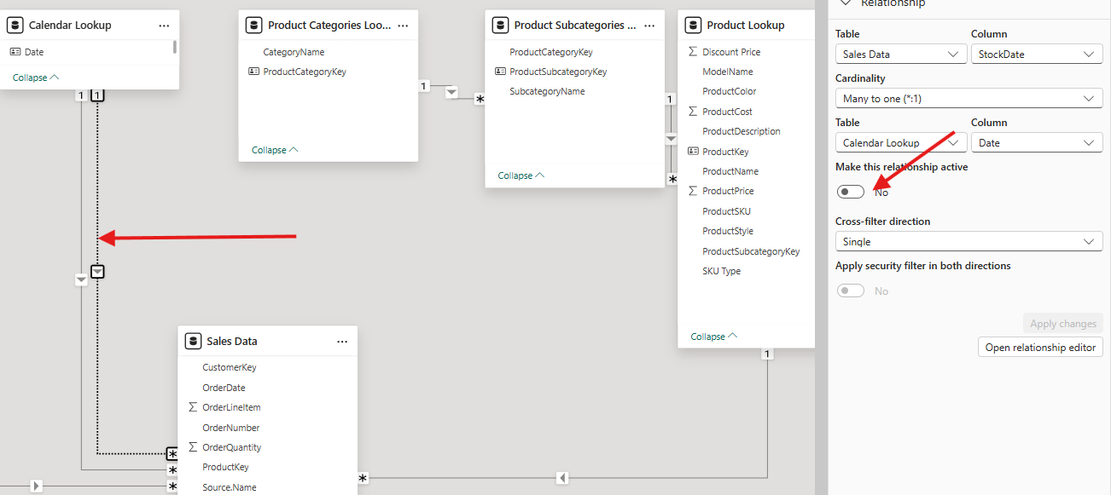
KEY POINTS
- An active relationship does not have to connect to a formally defined primary key, but in a typical 1:* relationship, the 1-side must contain unique values. Power BI uses the active relationship as the default path for filtering data.
- Power BI can have active or inactive many-to-many (*:*) relationships, where values are not unique on either side.
- However, for a standard one-to-many (1:*) relationship, the column on the 1 side must be unique; the * side can contain duplicates.

WHY WE NEED INACTIVE RELATIONSHIP
- Think of an inactive relationship as a backup relationship.
- It's stored in the model but Power BI won't use it unless you explicitly ask for it.
Example
Sales Table | Date Table
  OrderID | OrderDate | ShipDate | Amount
  1 | 01-Jan | 03-Jan | 100
  2 | 02-Jan | 05-Jan | 200
  Date
  01-Jan
  02-Jan
  03-Jan
  05-Jan
You want to analyze sales by:
- Order Date
- Ship Date
Both columns can connect to the Date table.
- Date[Date] -------- Sales[OrderDate] (Active)
- Date[Date] -------- Sales[ShipDate] (Inactive)
Power BI allows only one active relationship because otherwise it becomes confused.
What Problem Does It Solve?
Suppose a user selects: January 3rd
Should Power BI show:
- Sales ordered on January 3rd?
- Sales shipped on January 3rd?
Both are valid questions.
If both relationships were active, Power BI wouldn't know which path to follow.
Therefore:
- OrderDate relationship = Active
- ShipDate relationship = Inactive
When Do We Use the Inactive Relationship?
Suppose your report already shows:
Sales by Order Date
Total Sales =
SUM(Sales[Amount])
When a user selects Jan 2:
Result = 200
because Power BI uses the active OrderDate relationship.

Now Business Asks:
"Show sales based on Ship Date."
Create a measure:
Sales by Ship Date =
CALCULATE(
SUM(Sales[Amount]),
USERELATIONSHIP(
Sales[ShipDate],
Date[Date]
)
)
Now if the user selects Jan 5:
Result = 200
because the inactive ShipDate relationship is temporarily activated.

Inactive relationships are used when there are multiple valid relationships between two tables. Power BI allows only one active relationship to avoid ambiguity. The inactive relationship can be activated in a DAX measure using USERELATIONSHIP() whenever alternative analysis is required, such as analyzing sales by Ship Date instead of Order Date.
Rule of Thumb
Use Inactive Relationships whenever:
- One fact table has multiple date columns
- Multiple possible relationships exist between the same tables
- You need alternate filtering logic in specific measures

MODEL SCHEMA
A model schema is the way tables are organized and connected through relationships inside a Power BI data model.
Schema = the blueprint showing how your Fact and Dimension tables are connected.
For example, suppose you're building a retail Sales dashboard with:
- Sales
- Products
- Customers
- Dates
- Categories
- Countries
How you arrange and connect these tables determines your schema.
Two common schemas are:
- Star Schema
- Snowflake Schema
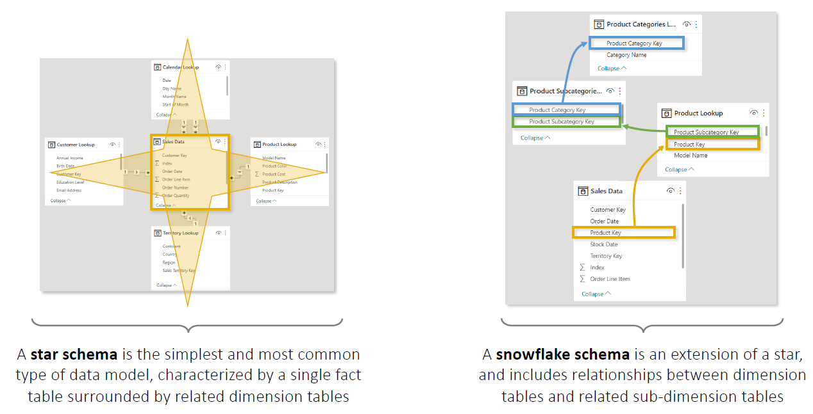

STAR SCHEMA
A Star Schema has:
- One central Fact table
- Multiple Dimension tables directly connected to the Fact table
It looks like a star, which is where the name comes from.
Example
Suppose we have a Sales Fact table:  And dimensions:  Product  Customer  Date | 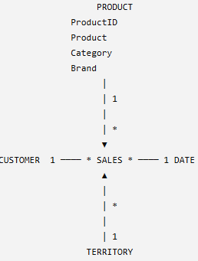
  OrderID | ProductID | CustomerID | DateID | Sales
  101 | P01 | C01 | D01 | ₹50,000
  102 | P02 | C02 | D02 | ₹30,000
  103 | P01 | C03 | D03 | ₹20,000
  ProductID | Product | Category | Brand
  P01 | Laptop | Electronics | Dell
  P02 | Chair | Furniture | IKEA
  CustomerID | Customer | City | Country
  C01 | Amit | Delhi | India
  C02 | John | London | UK
  DateID | Date | Month | Year
  D01 | 1-Jan | January | 2026
  D02 | 2-Jan | January | 2026

  - Note: Every Dimension directly connects to the Fact table.

SNOWFLAKE SCHEMA
- A Snowflake Schema is similar to a Star Schema, but some Dimension tables are further divided into additional related tables.
- Star → Dimensions connect directly to Fact
- Snowflake → Dimensions may connect to other Dimensions
Example
In our Star Schema, the Product table contained:  - Notice In above table -Category information is inside Product.  - In a Snowflake design, we might separate Category.  Product  Category | 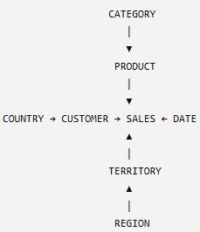
  ProductID | Product | Category | Brand
  P01 | Laptop | Electronics | Dell
  P02 | Mouse | Accessories | Logitech
  ProductID | Product | CategoryID
  P01 | Laptop | CAT01
  P02 | Mouse | CAT02
  CategoryID | Category
  CAT01 | Electronics
  CAT02 | Accessories

CARDINALITY
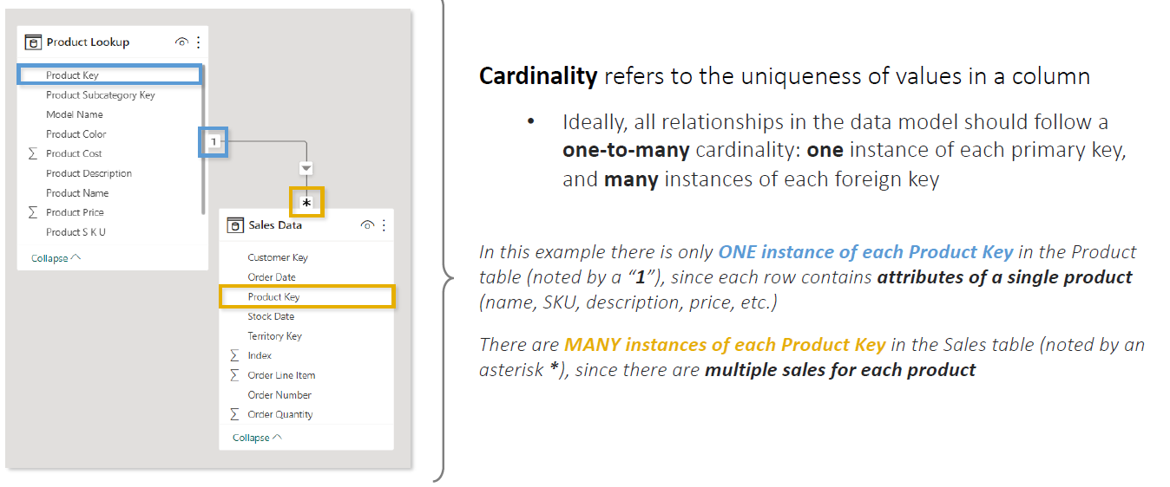

CONNECTING MULTIPLE FACT TABLE
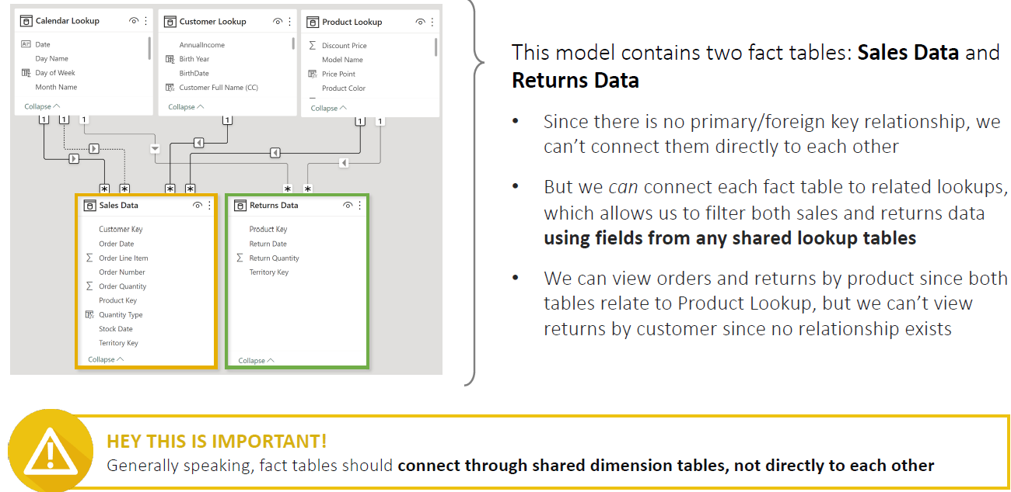
- A Power BI model can contain more than one Fact table.
- In the example:
  - Sales Data = sales transactions
  - Returns Data = product return transactions
- In a star schema, fact tables are generally not connected directly to each other. Instead, they are connected through one or more shared dimension (lookup) tables that contain common business entities such as Date, Customer, Product, Employee, etc.
- A dimension table does not necessarily need to contain columns from both fact tables. Rather, it contains the business key that both fact tables reference.

EXAMPLE
FactSales | FactOrders | DimCustomer
  CustomerID | ProductID | SalesAmount
  101 | P1 | 100
  102 | P2 | 200
  CustomerID | OrderCount
  101 | 5
  102 | 8
  CustomerID | CustomerName
  101 | John
  102 | Mary

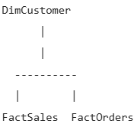 | - Both fact tables are connected to DimCustomer.  - There is no relationship between FactSales and FactOrders.
Why Not Connect Fact Tables Directly?
Suppose you create: FactSales <----> FactOrders
Problems:
- Many-to-many issues
- Ambiguous filter paths
- Duplicate aggregations
- Poor performance
Therefore, Power BI best practice is: Fact Table --> Dimension Table <-- Fact Table
- Multiple fact tables should typically not be related directly. Instead, they are connected through shared dimension (lookup) tables known as conformed dimensions.
- These dimensions contain common business keys, such as CustomerID, ProductID, or DateKey, which allow both fact tables to be filtered consistently.
- This approach avoids many-to-many relationships, reduces ambiguity, and follows the star schema design recommended for Power BI.
Rule to Remember
- Fact → Dimension
- Fact → Dimension ← Fact
- Fact ↔ Fact (avoid unless there is a very specific requirement)

EXAMPLE 2
Don't Directly Connect Fact Tables  - Sales and Returns contain repeated Product Key, Date, Territory Key, etc.  - Therefore, they should generally not be directly related to each other.  - Instead, connect both Fact tables through shared Dimension/Lookup tables. | 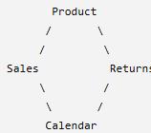
2. Connect Each Fact to Relevant Dimensions  Returns can connect through:  - Product Key → Product Lookup  - Return Date → Calendar  - Territory Key → Territory Lookup | 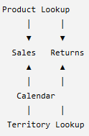
3. Shared Dimensions Can Filter Both Fact Tables  Because Product, Calendar, and Territory connect to both Sales and Returns, they can filter measures from both tables.  For example: | So you can create a report like:  Sales & Returns by Product
  Analysis | Possible?
  Sales & Returns by Product | ✅
  Sales & Returns by Country | ✅
  Sales & Returns by Date | ✅
  Product | Order Quantity | Return Quantity
  Bike | 1,000 | 50
  Helmet | 600 | 20
- Multiple Fact tables should generally connect through shared Dimension tables rather than directly to each other.
- A Dimension can filter a Fact table only when a valid relationship/filter path exists between them.

FILTER FLOW
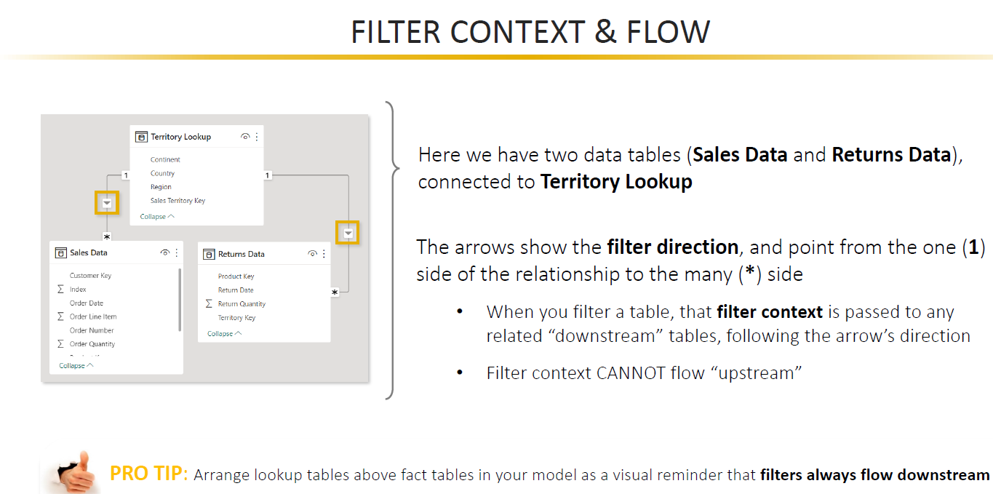
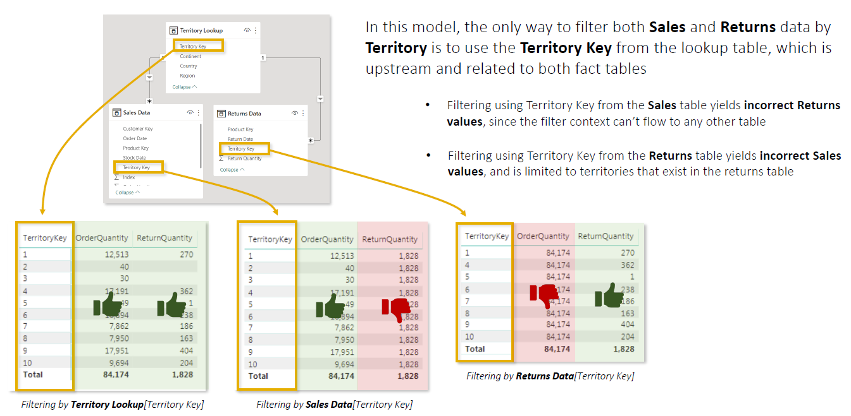
- Filter Context = Which data should be considered?
- Filter Flow = How does that filtering instruction travel through the data model?
They work together, but they are not the same thing.
- The difference becomes much easier if you think of filter context as "what is currently filtered" and filter flow as "where that filter is allowed to travel."

WHAT IS FILTER CONTEXT?
- Filter context is the set of filters that are active when Power BI evaluates a measure.
- Filter Context = Which subset of data should Power BI use for this calculation?
Suppose you have this Sales table: | And a measure:  Total Sales =  SUM(Sales[Sales])  Without any filter:  Total Sales = 100 + 200 + 300 + 400  = 1000
  Country | Product | Sales
  India | Laptop | 100
  India | Phone | 200
  USA | Laptop | 300
  USA | Phone | 400
Now suppose you select Country = India in a slicer.
The filter context becomes: Country = India
Therefore, Power BI calculates the measure using only:
Country | Product | Sales
India | Laptop | 100
India | Phone | 200
So: Total Sales = 300
That active condition, Country = India, is part of the filter context.
- Filter context can come from slicers, visual rows/columns, page/report filters, DAX functions such as CALCULATE, and filters propagated through relationships.

WHAT IS FILTER FLOW?
- Filter flow is the direction in which filter context can propagate from one table to another through relationships.
- In simple words:Filter Flow = Where can the filter context travel?
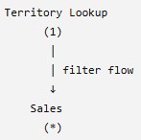 | The relationship is:  Territory Lookup (1) → Sales (*)  So a filter applied to Territory Lookup can flow into Sales
How Filter Context and Filter Flow Work Together
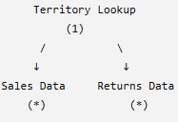 | - Both relationships have filter flow from the lookup table toward the fact tables.

Territory Lookup | Sales | Returns
  Territory Key | Country
  1 | India
  2 | USA
  3 | UK
  Territory Key | Sales
  1 | 100
  1 | 200
  2 | 500
  3 | 300
  Territory Key | Returns
  1 | 10
  2 | 20
  3 | 30
MEASURES | Total Sales =  SUM(Sales[Sales]) | Total Returns =  SUM(Returns[Returns])\

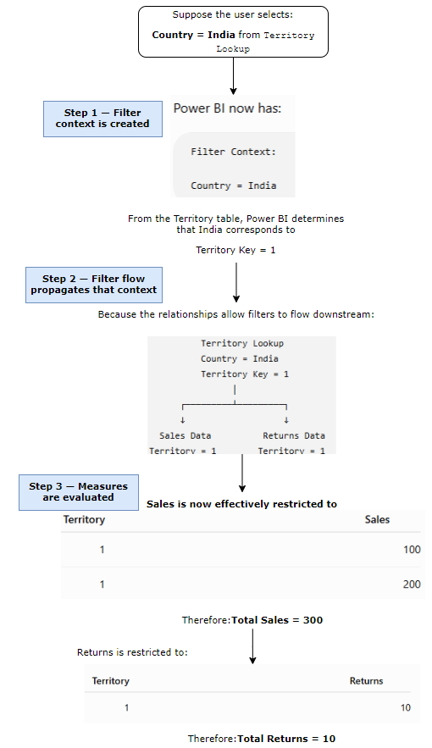
- Filter context tells Power BI WHAT is filtered. Filter flow tells Power BI WHERE that filter can propagate.

FILTER CONTEXT TELLS WHICH DATA SHOULD I CALCULATE?
Filter Context = the set of filters currently affecting a calculation.
Imagine your company has sales across:
- India
- USA
- UK
And your report has a slicer:Country = India
By selecting India, you are telling Power BI:"For the calculation I'm looking at, consider only data related to India."
That condition is part of the filter context.

Similarly, if the user selects:
- Country = India
- Year = 2026
- Product = Laptop
Power BI effectively receives the instruction:"Calculate the result only for Laptop sales in India during 2026."
That collection of filters is the filter context.
So:Filters can come from slicers, visual rows/columns, page/report filters, DAX, and other report interactions.

FILTER FLOW TELLS - HOW DOES THAT FILTER REACH THE DATA?
- Now Power BI has:Country = India
- But Country might be stored in a Territory Dimension, while Sales Amount is stored in the Sales Fact table.
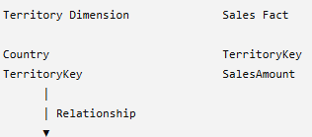
- Power BI needs a way to take: Country = India and determine which Sales rows belong to India. This is filter flow.  - Filter Flow = the path that filter context follows through relationships between tables.  THINK OF RELATIONSHIPS AS PIPES |  | 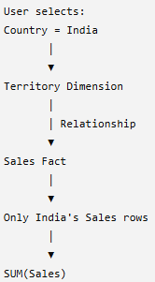
A useful analogy is water flowing through pipes.  The filter context is the water:"India"  The relationship is the pipe: Territory ─────────► Sales  The filter travels through that pipe:  - The relationship's filter direction determines which way the filter is allowed to travel. | 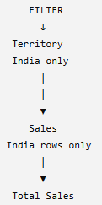
- Dimensions provide the context. Facts provide the numbers.
- For example:"What are Sales for Laptop in India during 2026?"
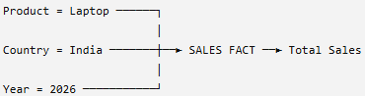
All three filters flow into Sales before the measure is calculated.

WHY DOES FILTER DIRECTION MATTER?
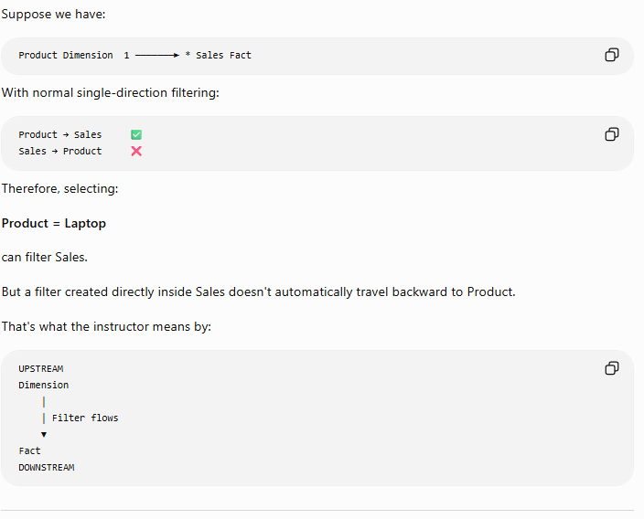
- In Star Schema, the recommended and most common setup is: Dimension (1) → Fact (*) ✅
- For example:Product Dimension (1) → Sales Fact (*)
- However, Power BI also supports bidirectional filtering, where filters can flow both ways: Dimension (1) ↔ Fact (*)
- Bidirectional relationships should be used only when needed because they can create ambiguous filter paths and make the model more complex.
Rule to remember: For most Power BI models, start with single-direction filtering from Dimension → Fact.

HIERARCHIES

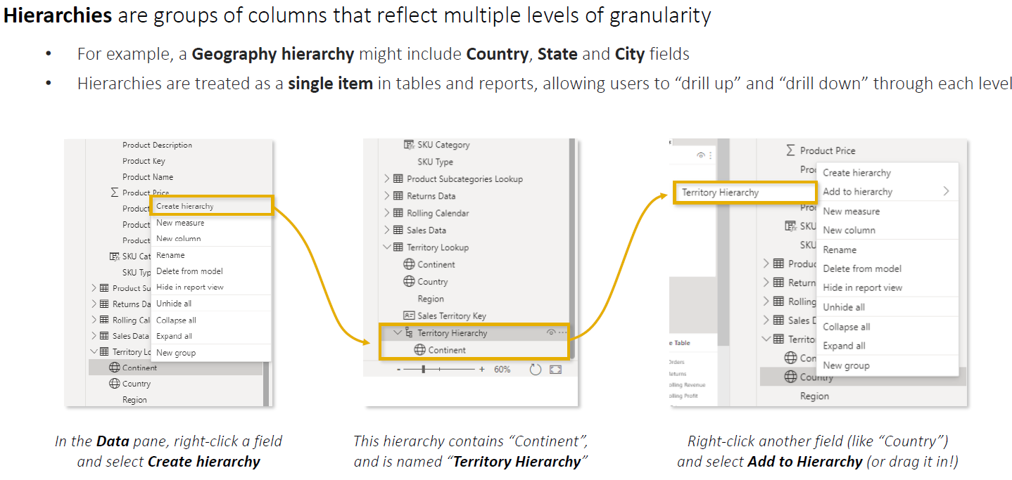
- A hierarchy in Power BI is an ordered collection of related columns arranged from a higher level to a more detailed level, allowing users to drill down and drill up in a visual.
- For example, a geographical hierarchy could be:
If the data is:  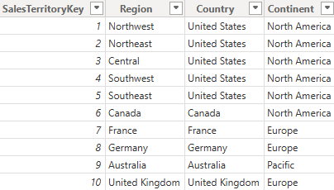 | Geography Hierarchy  │  ├── Continent  ├── Country  └── Region

HOW TO CREATE HIERARCHY
Example: Territory Hierarchy
We want to create: Continent → Country → Region
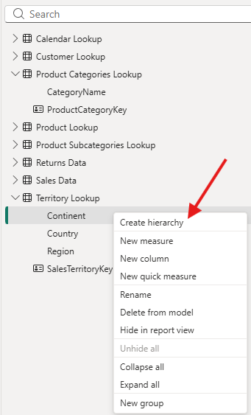 | - Go to any view that shows the Data pane. You can create a hierarchy from Report View, Data View, or Model View.  - Start with the highest-level field.  - In this example, the highest level is Continent.  - In the Data pane, right-click Continent and select Create hierarchy.  - Rename the hierarchy.  - Power BI creates a new hierarchy object containing Continent.  - Double-click its name and rename it, for example, to Territory Hierarchy. At this point it looks like:
 | 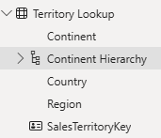
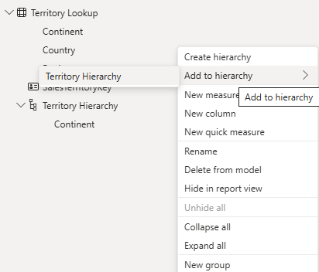 | - Add the next field: Country. Right-click Country → Add to hierarchy → select Territory Hierarchy.  - Add Region. You can use the same right-click method, or simply drag Region and drop it into the hierarchy. The completed hierarchy is:  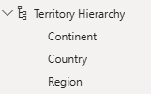  The order is important because it determines the drill path:  Continent → Country → Region

USING THE HIERARCHY IN A MATRIX
Now create or select a Matrix visual and drag the entire Territory Hierarchy into the Matrix's Rows area.
Initially, Power BI displays the highest level:
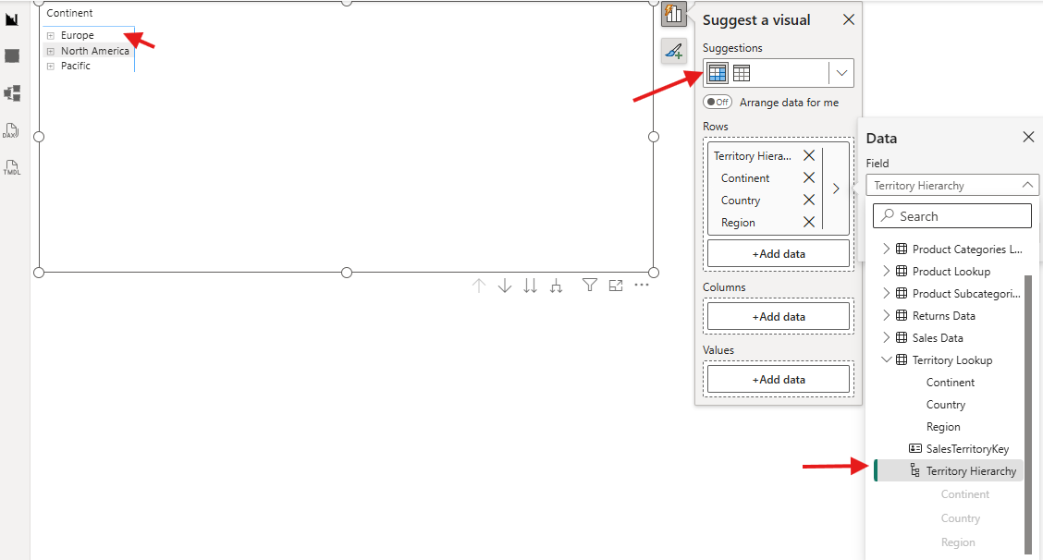

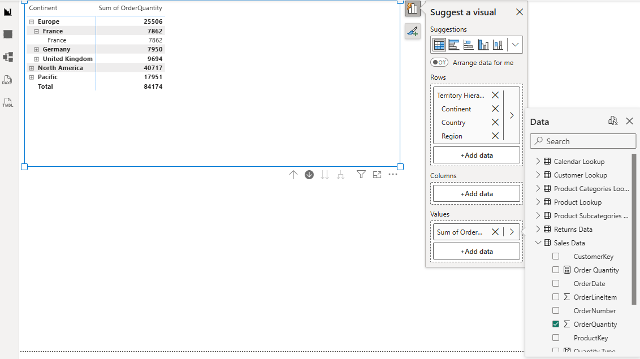

DRILL FEATURES

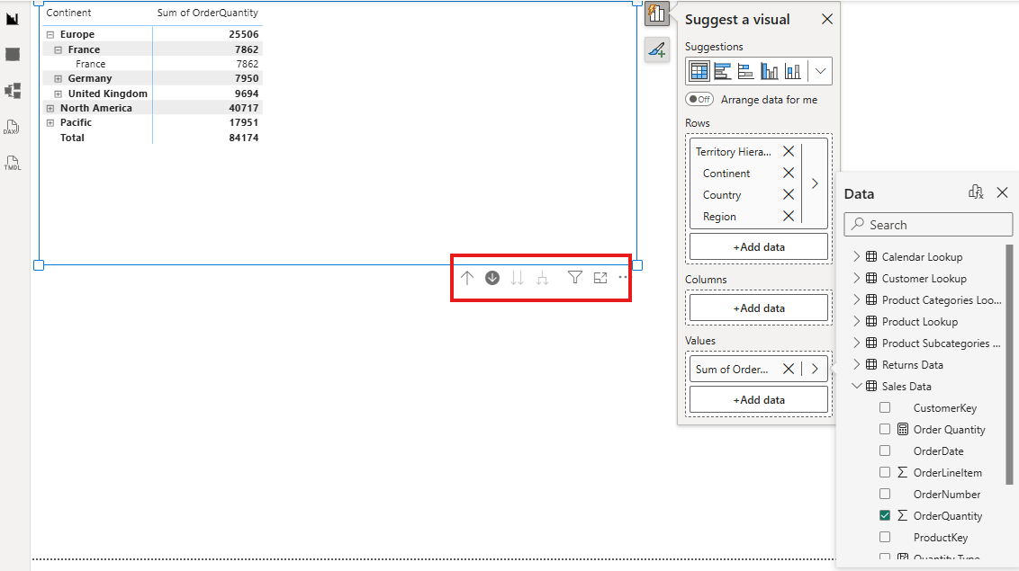
Drill Features in a Power BI Matrix
- Drill features allow you to navigate through different levels of a hierarchy in a Matrix visual, moving from summarized information to detailed information and back.
- Suppose you created this hierarchy: Territory Hierarchy = Continent Country Region
- And your Matrix contains Territory Hierarchy in Rows and Total Sales in Values.

Continent | Sales
Europe | 500,000
North America | 800,000
Pacific | 300,000
- Drill Down → Go deeper for a selected item
- Next Level → Move the whole visual to next level
- Expand All → Show parent + child together
- Drill Up → Go back to higher level

DAX(DATA ANALYSIS EXPRESSION)
- DAX (Data Analysis Expressions) is the formula language used in Power BI to perform calculations and analyze data in the semantic model.
- Think of DAX as similar to Excel formulas, but designed to work with tables, relationships, and filter context.
- DAX can be used in two keyways in Power BI:
- CALCULATED COLUMNS — mainly used when you need a new field/attribute in a table, often for categorizing, grouping, or filtering.
- MEASURES — used to calculate dynamic aggregated results such as Sum, Count, Average, etc.
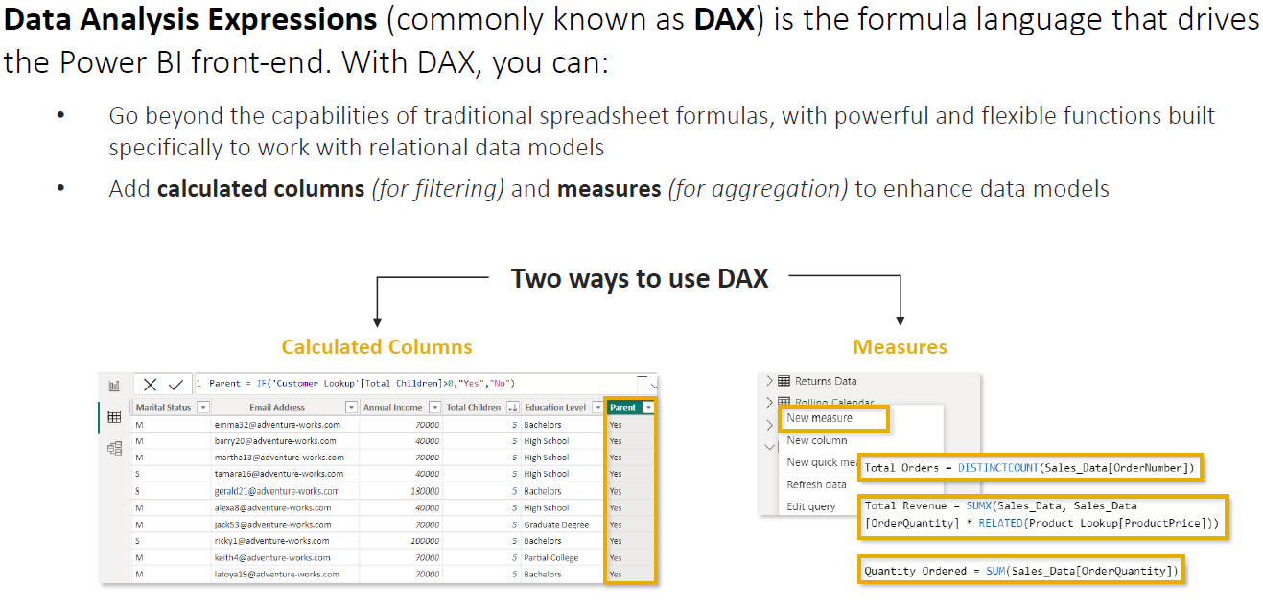

DAX AS A CALCULATED COLUMN
- A calculated column is a new column created inside an existing table using a DAX formula.
- The calculation is performed for each row.
- NOTE - Calculated Column = calculation for each row that creates a new field in the table.
Suppose we have a Customer table: | We want a new column called Parent.  We could write:  Parent =  IF(  'Customer'[Total Children] > 0,  "Yes",  "No"  ) | Power BI evaluates the formula for every row:
  Customer | Total Children
  John | 2
  Mary | 0
  David | 3
  Sarah | 0
  Customer | Total Children | Parent
  John | 2 | Yes
  Mary | 0 | No
  David | 3 | Yes
  Sarah | 0 | No
Because Parent is now a column, you can use it in slicers, filters, rows, columns, grouping, etc. For example, you could create a slicer: Parent
☐ Yes
☐ No
Selecting Yes would filter the report to customers who have children.

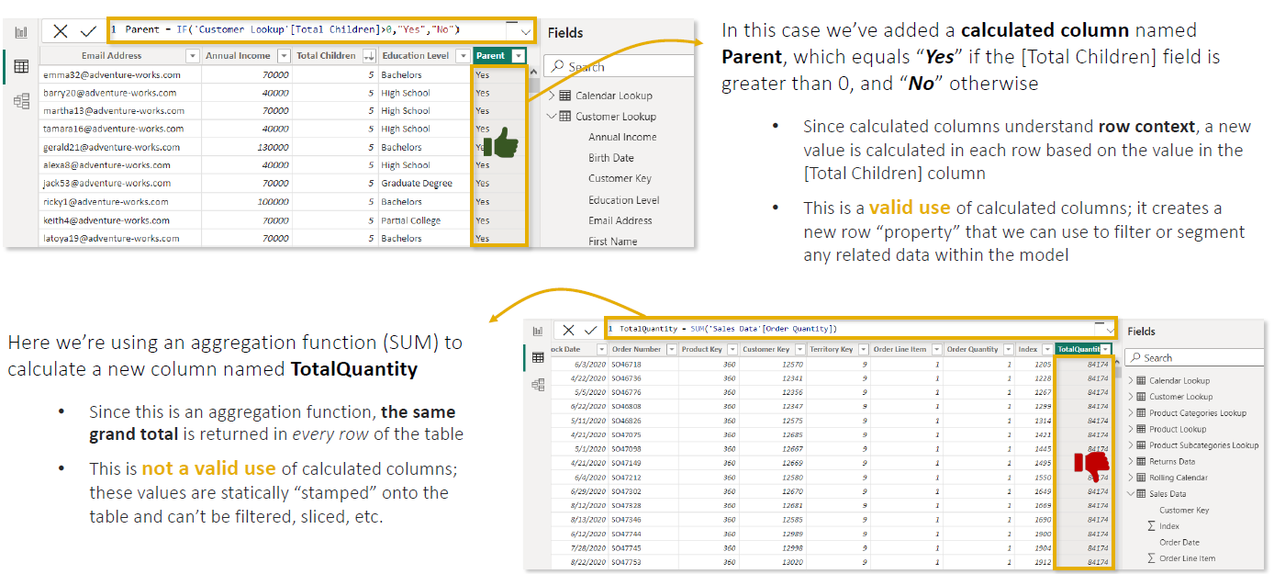

NOTES
- Calculated Columns create a new formula-based column in a table within the Power BI semantic model.
- Unlike Excel, DAX does not use cell references like A1 or B5; formulas reference tables and columns.
- The calculated results are visible in Data View and become part of the model.
- Calculated columns work using Row Context:
  - Power BI evaluates the formula one row at a time.
  - The calculation can use values from the current row.
- Calculated columns are generally not the right choice for aggregations such as Total Sales, Total Quantity, Average Sales, etc. We use measures for such use case.

STEPS TO CREATE CALCULATED COLUMN
- Click on Table or Column New Column
- Write the DAX Query
Quantity Type =
IF('Sales Data'[OrderQuantity] > 1 ,"Multiple Items","Single Item")

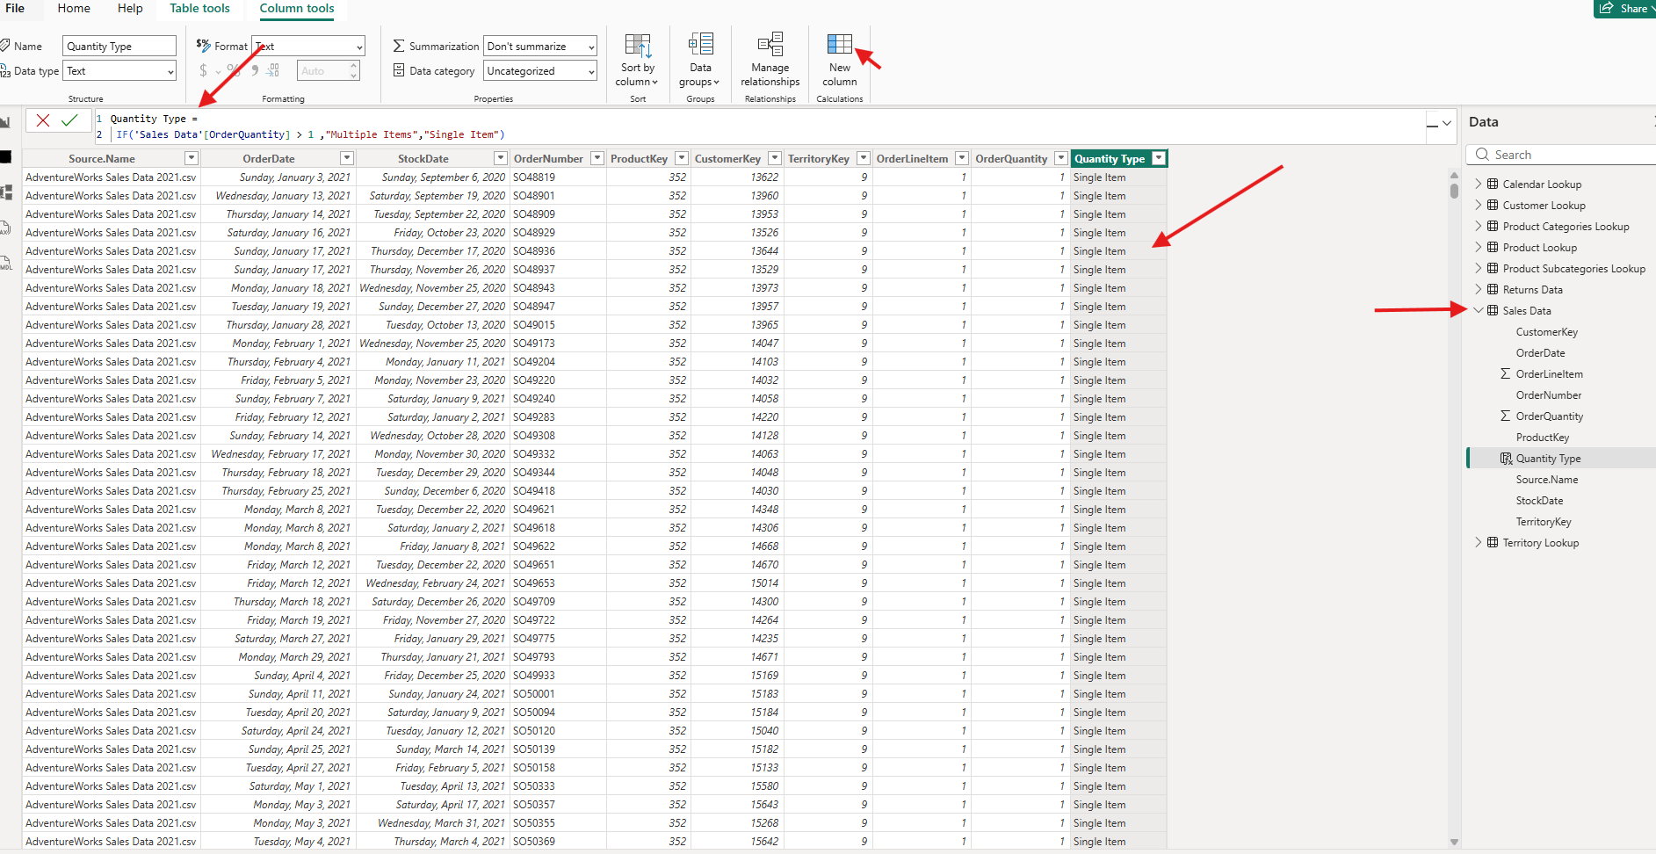

DAX AS A MEASURE
- A Measure is a dynamic DAX calculation used to calculate an aggregated result based on the current filter context.
- Measures are commonly used for aggregations such as:
SUM, COUNT, DISTINCTCOUNT, AVERAGE, MIN, MAX, etc.

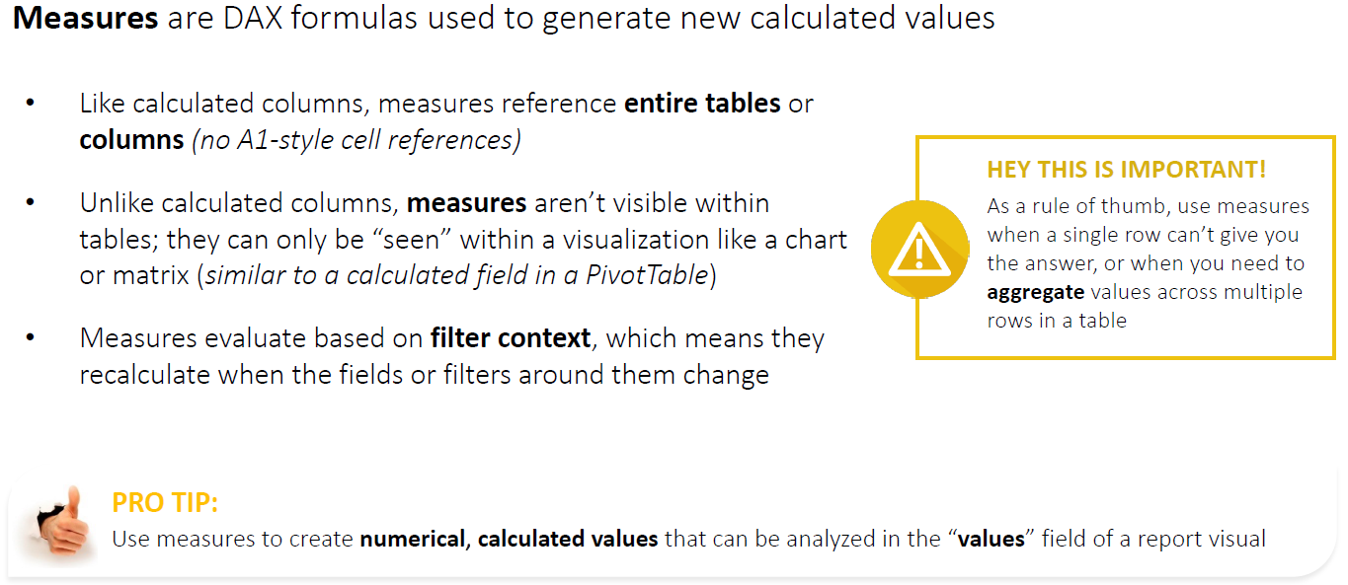

IMPLICIT AND EXPLICIT MEASURES
Both are used to aggregate numerical data, but the main difference is who creates the calculation:
  - Is it created by Power BI itself (Implicit Measure)
  - We created the DAX (Explicit Measure)

IMPLICIT MEASURE
An implicit measure is automatically created by Power BI when you drag a numeric column into the Values area of a visual.

Sales table contains | - When we drag Sales Amount into a visual. Power BI automatically uses: Sum of Sales Amount = ₹100,000  - These are explicit measure created by Power BI without we writing DAX. Power BI automatically aggregates a numeric column.  - Power BI lets you select aggregations such as:  - Sum  - Average  - Minimum  - Maximum  - Count
  Product | Sales Amount
  Laptop | 50,000
  Mobile | 30,000
  TV | 20,000

EXPLICIT MEASURE
- An explicit measure is a measure that we intentionally create using DAX.
- Examples
Total Sales =  SUM(Sales[Sales Amount]) | Now [Total Sales] becomes a reusable measure in your semantic model.
More advanced measures:
Total Profit =
SUM(Sales[Profit])

Profit Margin % =
DIVIDE(
[Total Profit],
[Total Sales]
)
- Explicit Measure = A named DAX measure created by the developer.

MEASURE TREE

HOW MANY NET ORDERS DO WE HAVE AFTER SUBTRACTING RETURNS?  Assume:  - Total Orders = 1,000  - Total Returns = 150  - Therefore: Net Orders = 1,000 – 15 = 850  We can create explicit measure for each | MEASURE 1 — TOTAL ORDERS  Total Orders =  DISTINCTCOUNT(Sales[Order Number])  Result: Total Orders = 1,000
MEASURE 2 — TOTAL RETURNS
Total Returns =
DISTINCTCOUNT(Returns[Order Number])

Result:Total Returns = 150
MEASURE 3 — NET ORDERS
Because Total Orders and Total Returns are explicit measures, another measure can reference them:
Net Orders =
[Total Orders] - [Total Returns]
Result: 1,000 - 150 = 850
Note: We're reusing existing measures instead of rewriting all of their underlying logic.
- In measure tree – one measure depends on other measure .For example,
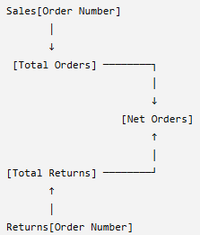 | 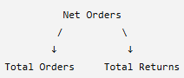  OR  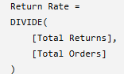

EXAMPLE

TABLE - Sales | MEASURES
 | Total Quantity =  SUM(Sales[Quantity])  Total Revenue =  SUMX(  Sales,  Sales[Quantity] * Sales[Price]  )  Average Revenue Per Unit =  DIVIDE(  [Total Revenue],  [Total Quantity]  ) | 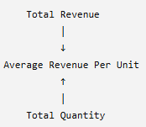
  Product | Quantity | Price
  Laptop | 2 | 500
  Phone | 5 | 200
  Tablet | 3 | 300
- Note(Reusability): Let’s say - If the definition of Total Revenue changes later, we update the base measure and calculations that reference it can continue using that measure.

EXPLICIT MEASURES ALSO RESPOND TO FILTER CONTEXT

Total Sales =  SUM(Sales[Sales Amount]) | Using our data:  ₹100,000  + ₹2,500  + ₹4,500  ──────────  = ₹107,000  So:Total Sales = ₹107,000
But here's what makes measures special: they are dynamic.  Suppose our data is: | The measure:  Total Sales =  SUM(Sales[Sales Amount])  initially returns:₹107,000  Now the user selects: Country = India  The same measure becomes:₹102,500  Then the user selects: Product = Laptop  It becomes:₹100,000  - The DAX formula didn't change. The filter context changed.  - Measure = Calculate the answer for the current filter context.
  Product | Country | Sales Amount
  Laptop | India | ₹100,000
  Mouse | India | ₹2,500
  Keyboard | USA | ₹4,500
Example 2
Suppose you have employee data:
 | Calculated Column  We want the Bonus Amount for every employee:  Bonus Amount =  Employee[Salary] * Employee[Bonus %]  Result:  That's a row-level calculation. | Measure  Now management asks:  "What is our total salary expense?"  Create:  Total Salary =  SUM(Employee[Salary])  Result:  ₹190,000  - If a report filter selects only one department, [Total Salary] automatically recalculates for that department
  Employee | Salary | Bonus %
  Amit | ₹50,000 | 10%
  Priya | ₹80,000 | 15%
  Rahul | ₹60,000 | 10%
  Employee | Salary | Bonus % | Bonus Amount
  Amit | ₹50,000 | 10% | ₹5,000
  Priya | ₹80,000 | 15% | ₹12,000
  Rahul | ₹60,000 | 10% | ₹6,000

CREATING EXPLICIT MEASURES

Step 1: CREATING MEASURE
- There are multiple ways to create a measure. In the below example – we will use the context menu new Measure by right clicking on the table, where we want to create the menu
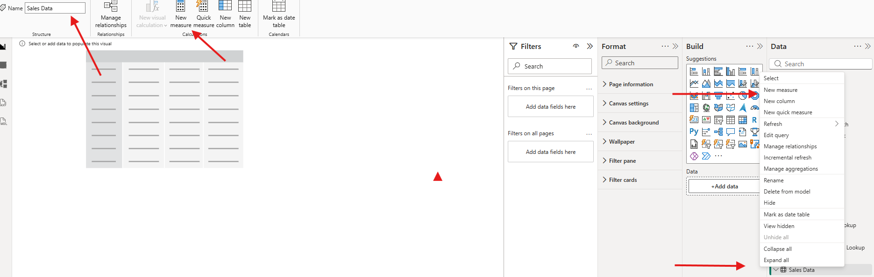

Step 2: WRITE DAX QUERY FOR MEASURES

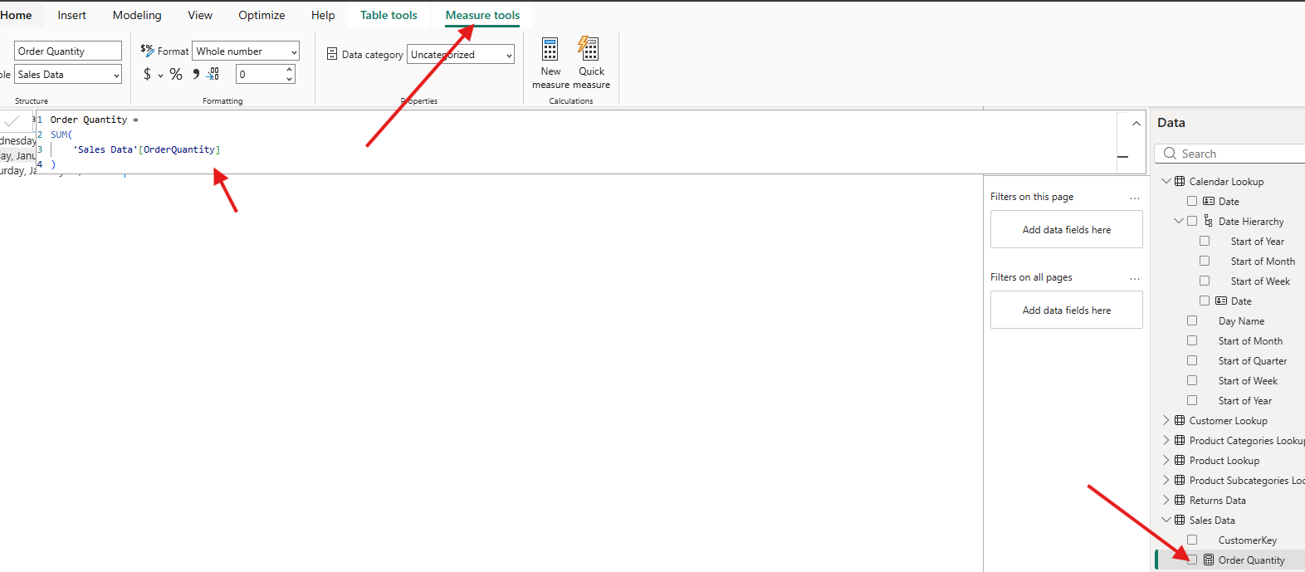

Step 3: USE MEASURES – DRAG AND DROP THE MEASURE IN DATA VIEW

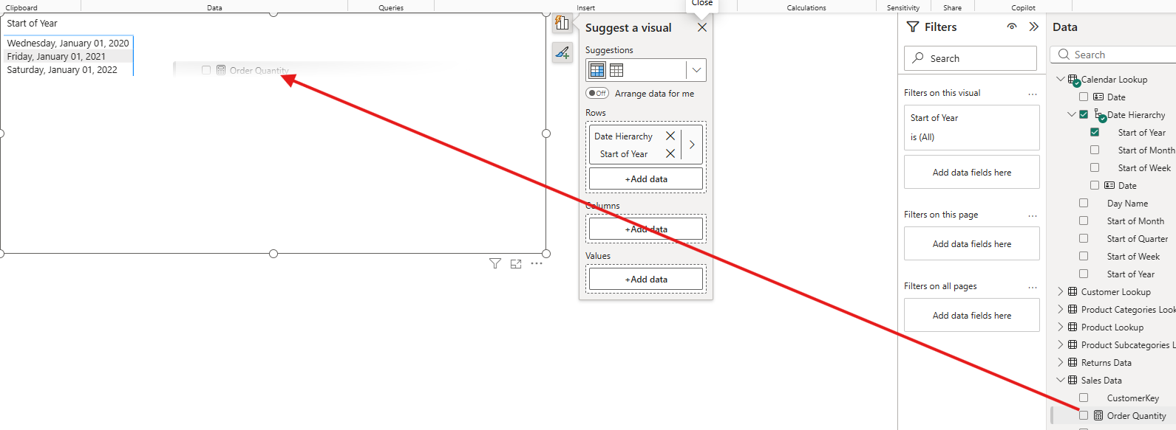

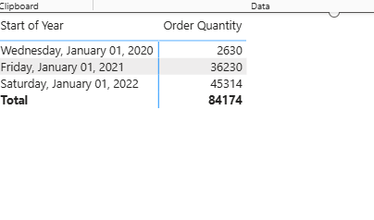

QUICK MEASURES
- Quick measures automatically create formulas based on pre-built templates or natural language prompts

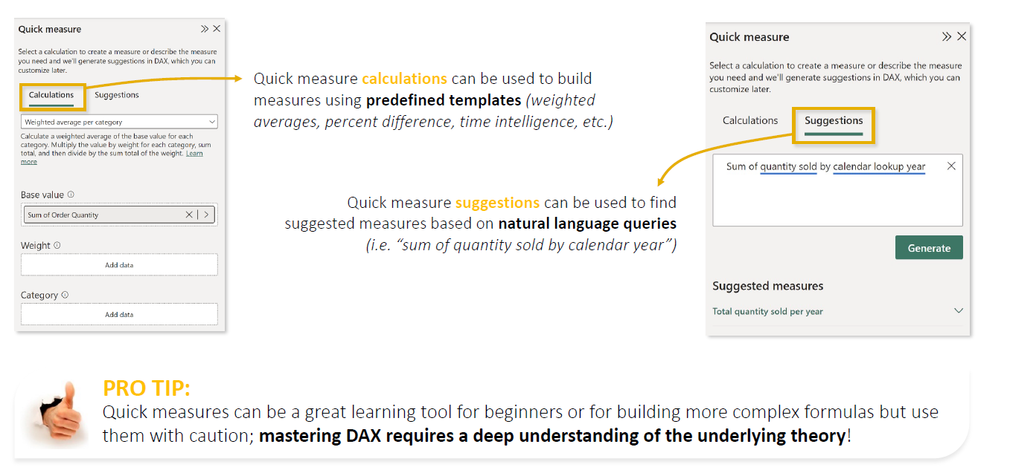

Suppose you already have a measure:  Total Sales =  SUM(Sales[SalesAmount]) | What percentage of total sales comes from each product category?  Instead of manually writing the DAX, we can create a Quick Measure and select a calculation such as Percent of grand total.  Power BI generates the required DAX for you.  The important point is that Power BI generated the DAX behind % of Total. | Your visual might then show:
  Category | Total Sales | % of Total
  Bikes | $600,000 | 60%
  Accessories | $250,000 | 25%
  Clothing | $150,000 | 15%
  Total | $1,000,000 | 100%

CALCULATED COLUMN VERSUS MEASURES

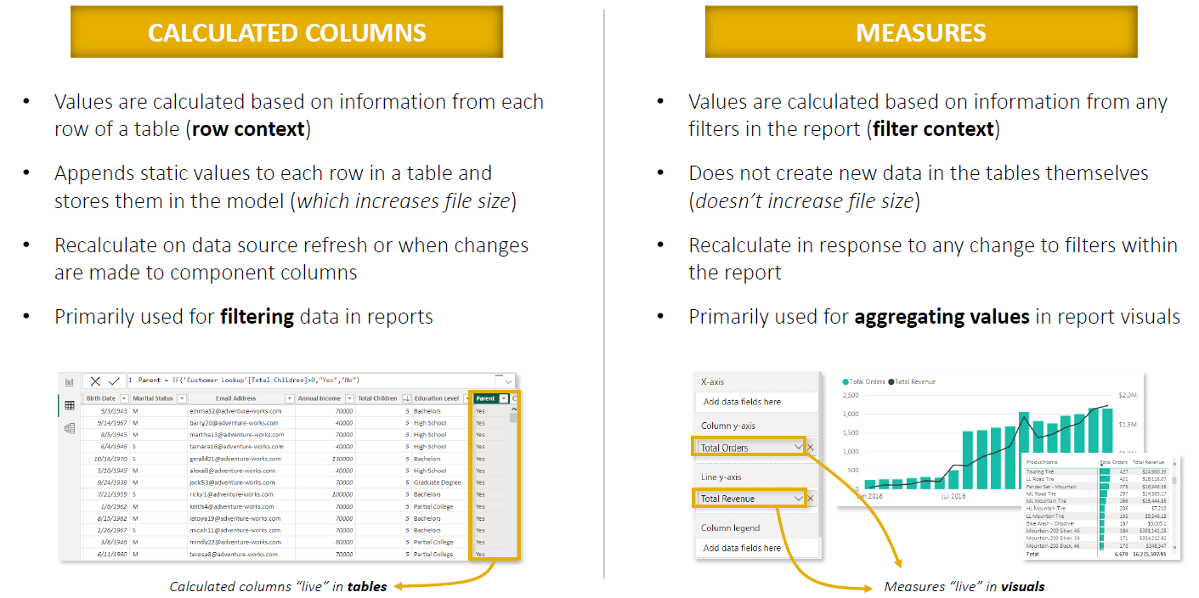

DEDICATED MEASURES TABLES
- A Dedicated Measures Table is a separate table created specifically to store and organize explicit DAX measures.
- It usually doesn't contain business data like Sales, Products, or Customers. Its main purpose is organization.
- Dedicated Measures Table = A central place in the Power BI model for storing your DAX measures.
- This becomes particularly useful when a model contains many measures.
- Imagine your AdventureWorks model contains:
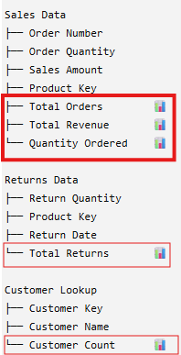 | - In the example(left) has measures are scattered across different tables.  - As the model grows, finding them becomes difficult.  - Instead, create a dedicated measures table to store the measures  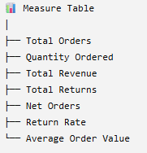  - Moving a measure to the Measure Table does not change how the calculation works.  - We're changing its Home table/organizational location, not the underlying data it calculates from

CREATING DEDICATED MEASURES TABLE

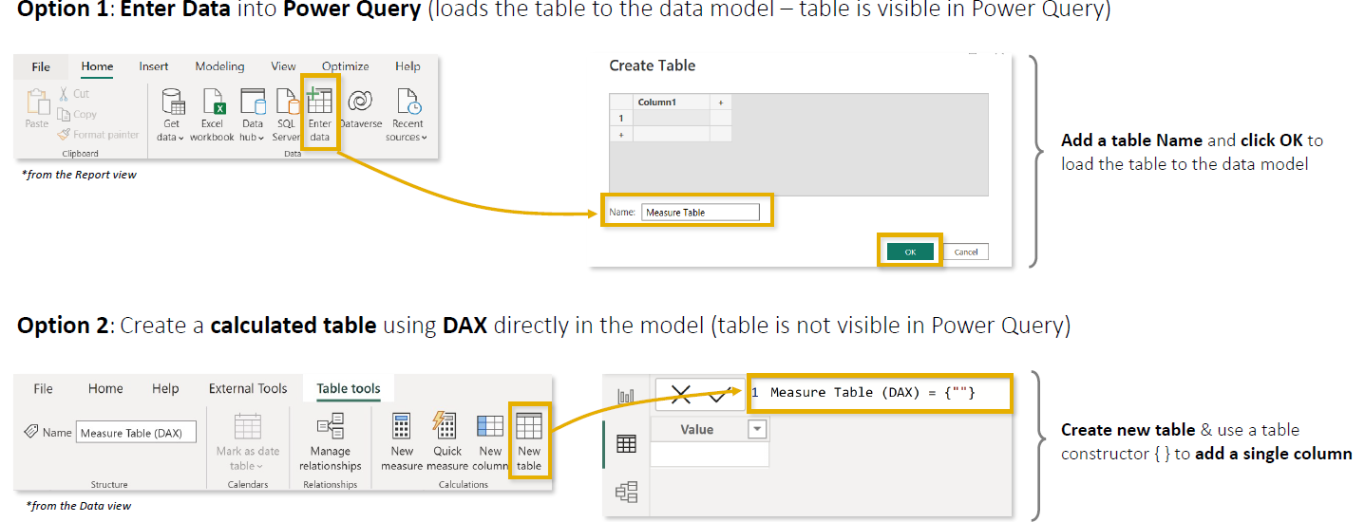

OPTION 1: ENTER DATA
Go to: Home → Enter data
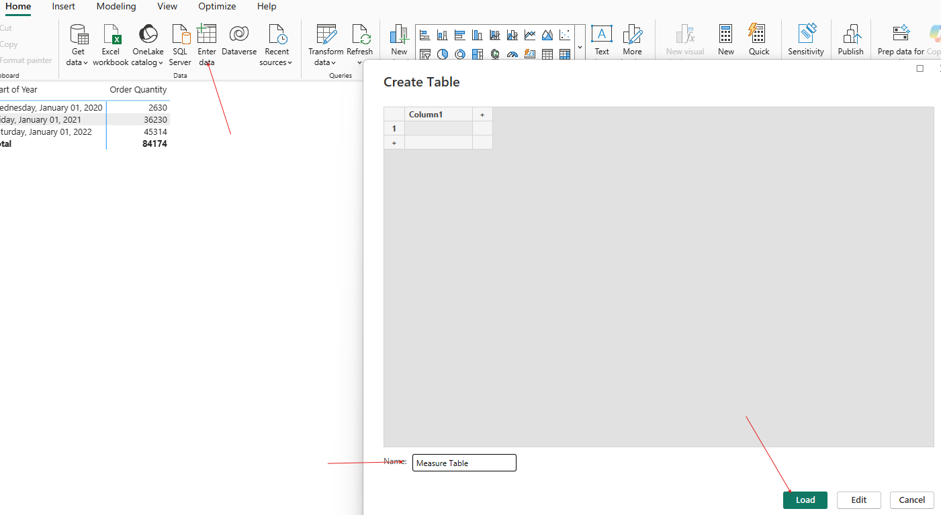
- Create a simple placeholder table (Name): Measure Table Load
- A benefit of this approach is that the table also appears in Power Query / Query Editor(Power BI Backend).

OPTION 2 — CREATE MEASURES TABLE USING DAX
- Go to: Table Tools → New Table
- Enter the DAX to create an empty table :
Measure Table (DAX) = { "" }
The { } syntax is a table constructor "Create a tiny placeholder table that I can use to hold my measures."
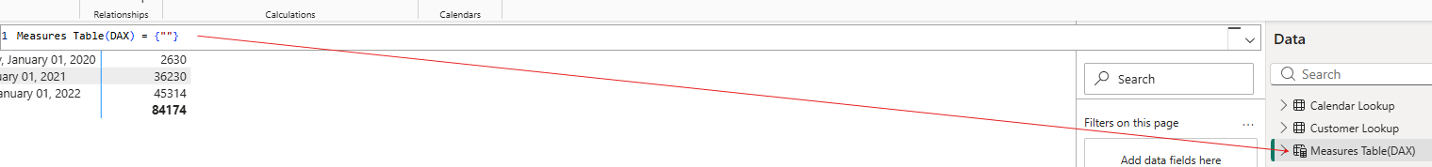
CREATES EMPTY MEASURES TABLE WITH A SINGLE VALUE COLUMN
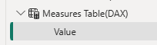

ADDING/MOVING MEASURES TO MEASURE TABLE
Suppose you already created this measure under Sales Data: Quantity Ordered
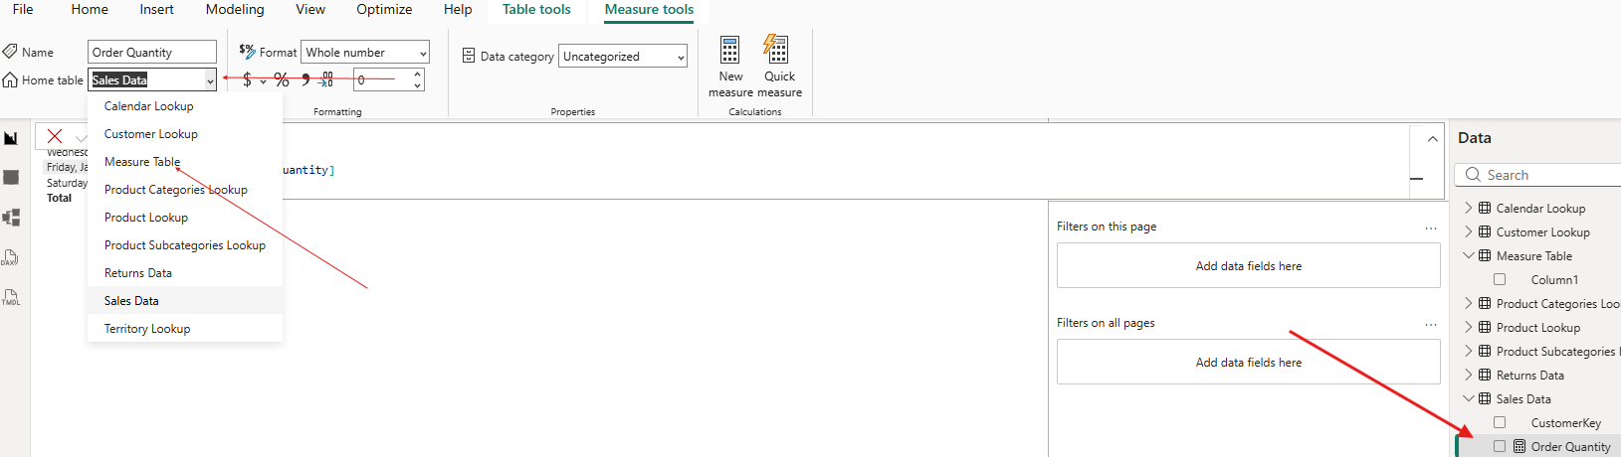
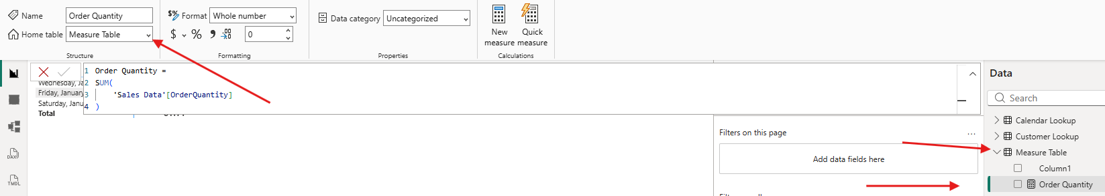
- Step 1: Select the Quantity Ordered measure.
- Step 2: Change its Home table property from: Sales Data Measure Table

DISPLAY FOLDERS

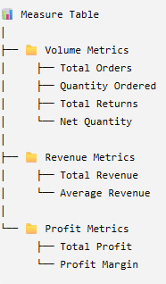 | - Imagine we eventually have multiple measures in the measures table. In such cases, even the Measure Table starts becoming cluttered.  - In such scenario – we can organize measures into Display Folders.  - For example, select the Quantity Ordered measure and set its Display folder property to: Volume Metrics  - Power BI then displays that measure under the Volume Metrics folder.  - This is organization only; it doesn't affect the DAX calculation.  - Navigate to Data Model View Update the display folder for a Measure(s)

